Preparing for AQA A level Business

Task 1: What is the hidden meaning behind each logo?
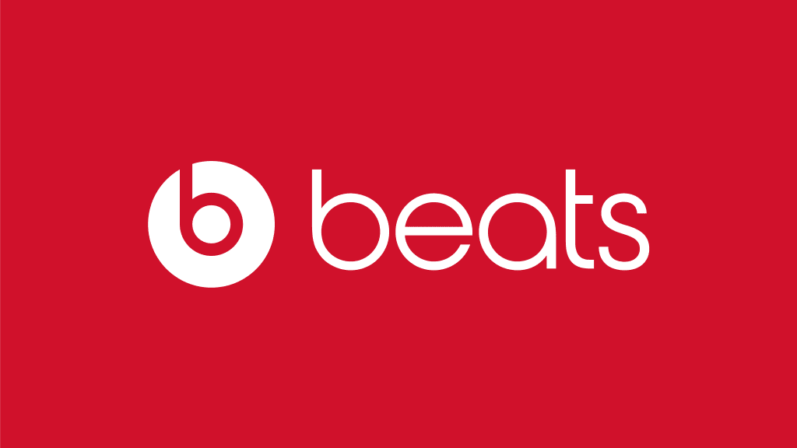 |  | 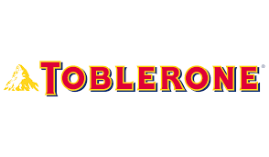
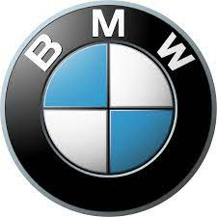
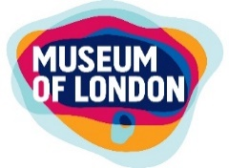

Task 2: Identify the typical characteristics of these industries
S (size and sector) | Primary sector – fishing; farming; mining | Secondary sector – manufacturing and construction | Tertiary sector – retail; hospitality; financial services | Quaternary sector – public sector; research and development
C (competition)
O (ownership and objectives)
R (resources)
E (external environment)

Task 3: Economy
Use the data to answer the questions.
Inflation is the pace at which prices are rising. For example, if a bottle of milk costs £1 and that rises by 5p compared with a year earlier, then milk inflation is 5%.  Currently, inflation is at the highest level since March 1982, when it also stood at 9.1% and the Bank of England has warned it will reach 11% this year.  Households were hit by an unprecedented £700-a-year increase in energy costs in April, and fuel price rises in June mean it costs more than £100 to fill an average family car with petrol. | 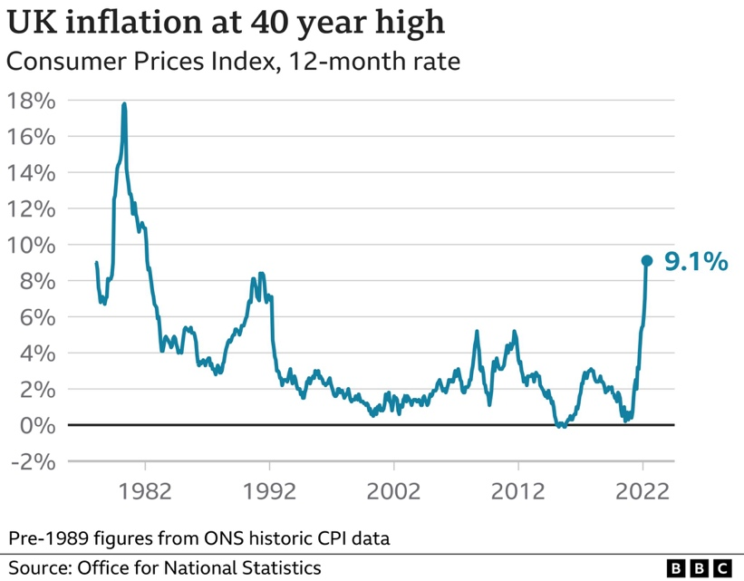 | 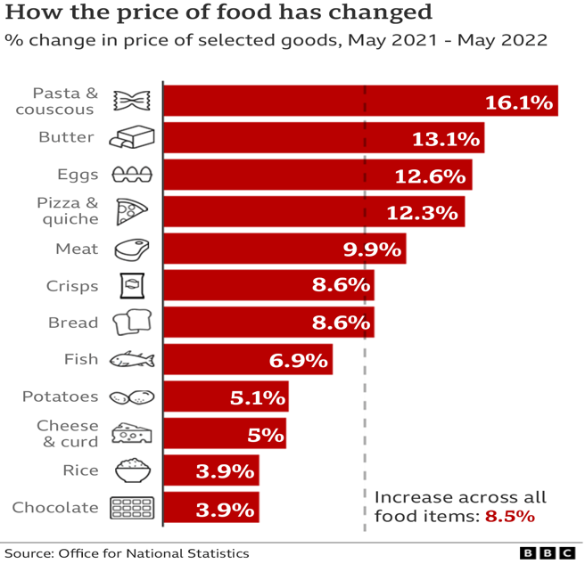

What has happened to interest rates? | What was the impact on businesses and consumers?

Why are we seeing these changes to the cost of living?

Task 4: What is happening to the economy? 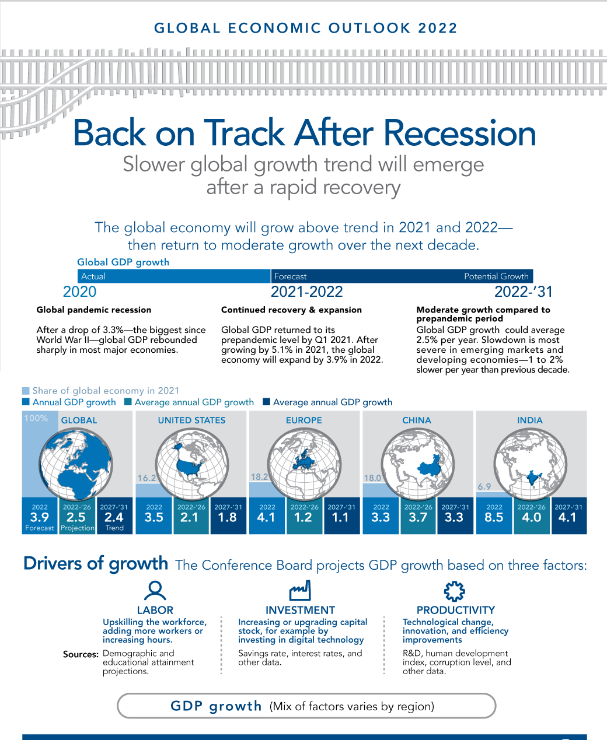 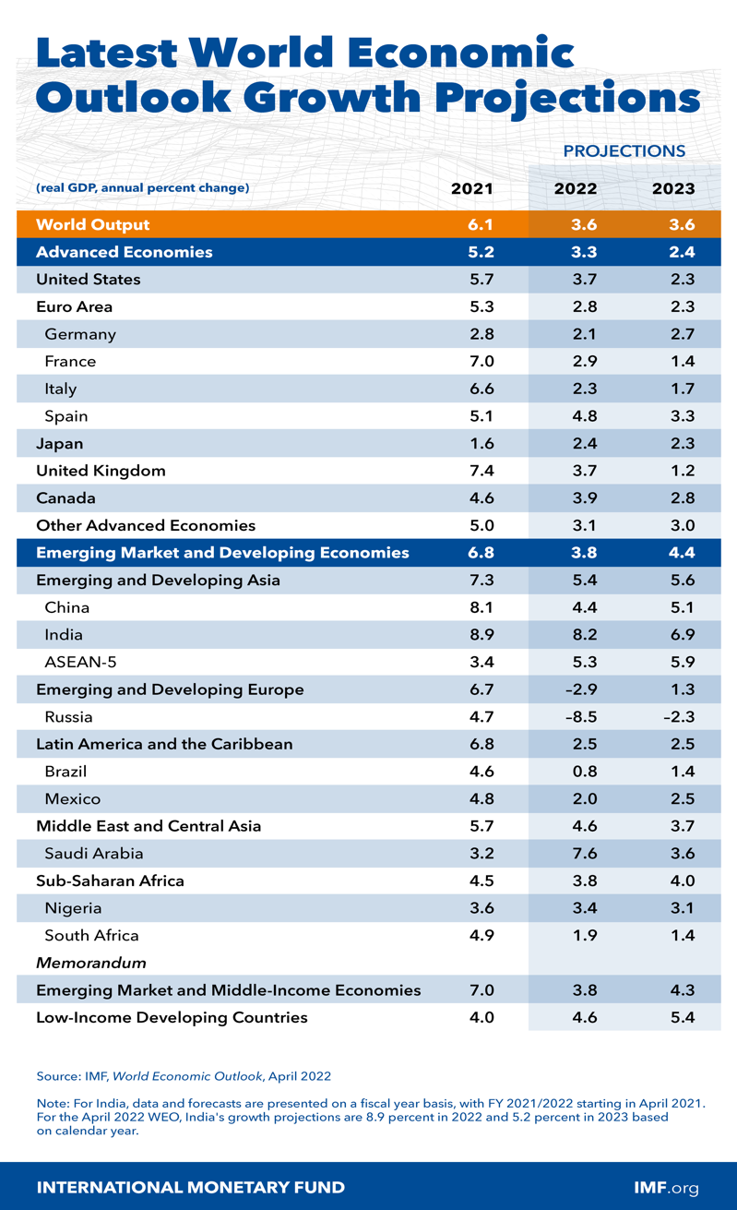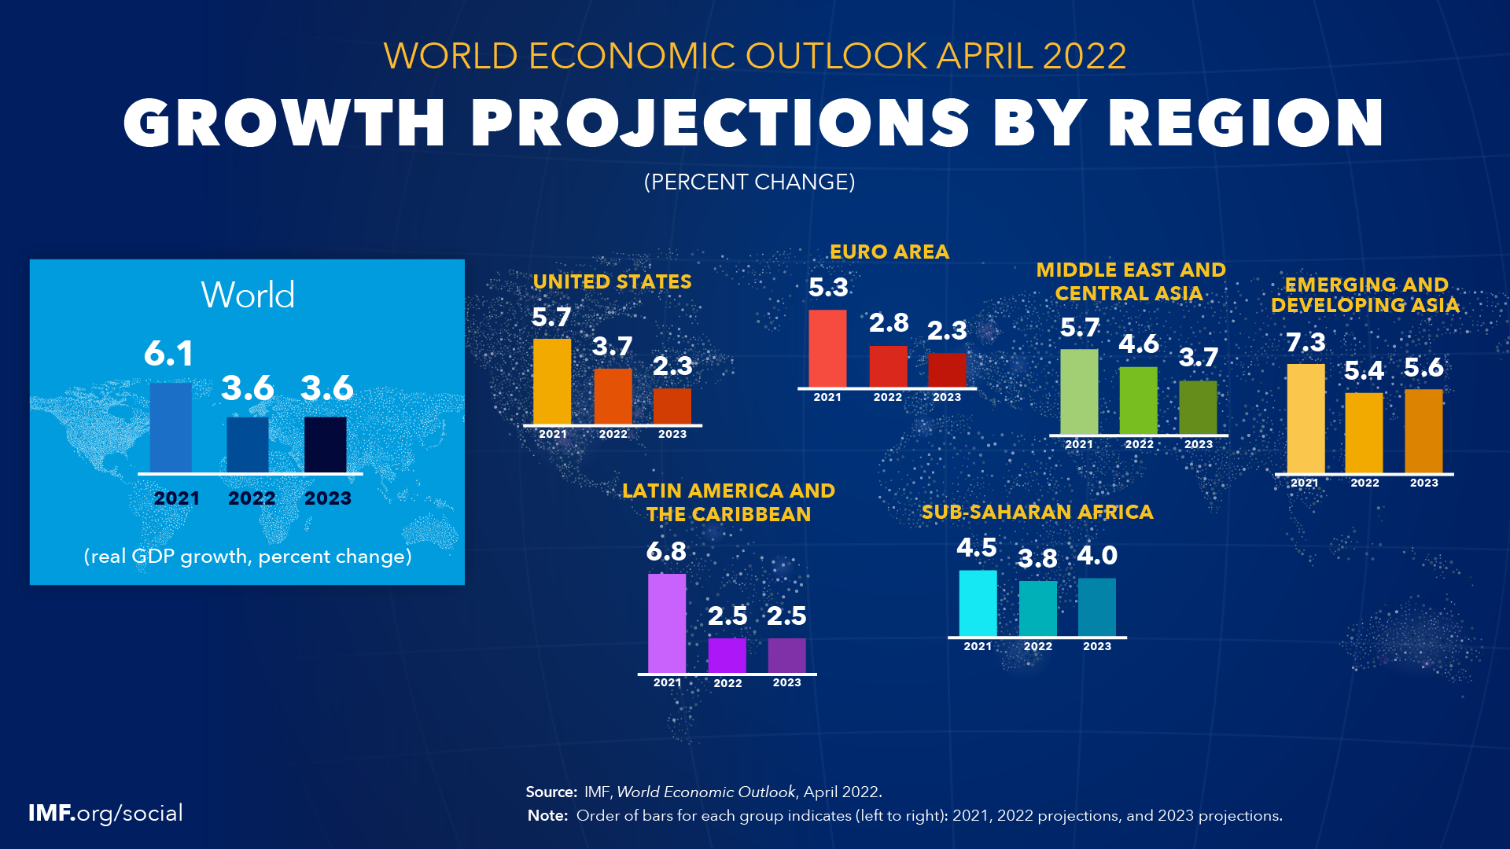
What is happening to different economies and why? | Are certain industries doing better than others? | What is the impact on small businesses?

Task 5: Pick four of her podcasts and identify 5 things you learn from listening to them
 | Start with “Making sense of the meltdown in markets”. Listen to the podcast and identify 5 things you learn from listening to this | Podcast 2: | Podcast 3: | Podcast 4:

Task 6: Learn these formulas. You will be tested on these in the first week and through your course

