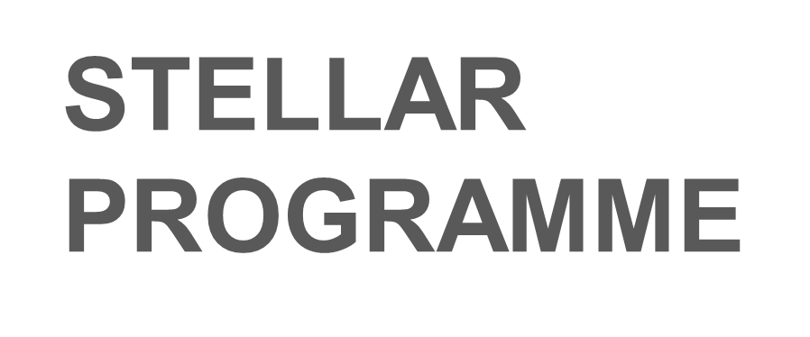

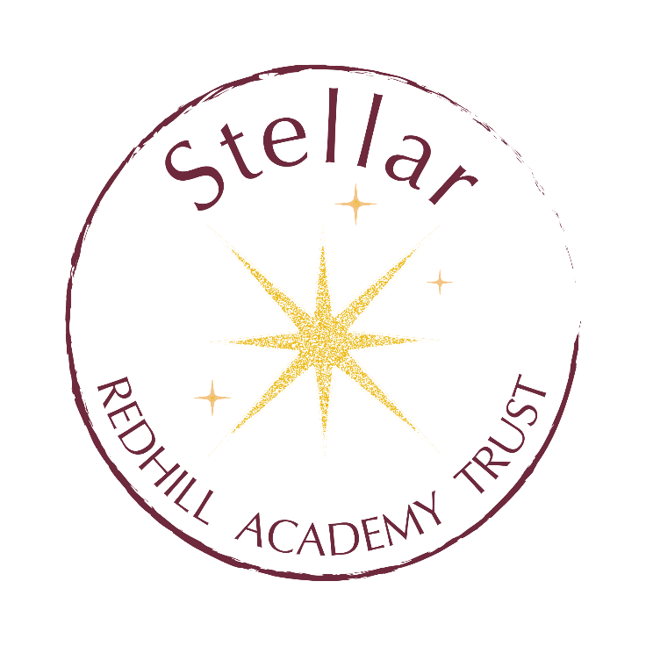



NAME: TUTOR GROUP:

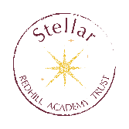
Stellar is split into four key areas of personal growth- below are examples of some of the activities you could do within each area.
What you can do

Community and Social Impact | Personal Growth | Academic Growth | Creative and Cultural
Participate in a fundraising event | Deliver a presentation to other students or adults | Read a book on your chosen subject | Join a school drama or music society/ club
Do reading or maths buddies in school | Complete a leadership training | Watch a subject lecture, live or online | Try a new language on a platform like Duolingo
Mentor, coach or support another student or young person | Read a book by an inspirational person | Attend a subject webinar or masterclass | Read news and feature articles online about what is happening in the world
Volunteer at a local charity | Try a new sport or serve as captain in one you already do | Read a journal article or research paper | Read a novel from another culture
Tutor younger students | Participate in a formal debate | Complete a MOOC | Listen to new music
Take part in a school or community clean up | Join the student committee or council | Engage in independent research | Do some art or craft activities in your spare time
Help elderly neighbours | Learn a new skill, e.g. coding | Complete an Online course | Design and build something
Campaign for a social issue | Take a first aid course | Watch a documentary | Read a genre you would not normally try
Take part in a march or parade in the community | Manage a personal project of your choice | Join or follow an academic society | Try a new musical instrument
Organise a donation or charity drive | Participate in the Duke of Edinburgh award | Participate in an academic or essay competition | Take part in a cultural celebration
Help out in lower school lessons | Join a school club or society | Listen to a podcast on your subject | Watch a foreign language film
Contribute to changing and improving the sixth form environment | Join a new club or activity out of school | Read a non-fiction book on a subject you are unfamiliar with | Read a novel about a perspective different to yours
Organise a school or community event | Research your family history | Write an article or paper on a subject that interests you | Submit writing to a magazine or online website.
Raise awareness of an issue | Read a self development book | Take the EPQ course | Enter a creative competition
A random act of kindness | A random act of kindness | A random act of kindness | A random act of kindness
Other Community and social impact activity | Other personal growth activity | Any other Academic growth activity | Any other creative or cultural activity.

How to improve
There are three stellar levels- Try, Commit, and Lead
Try | Commit | Lead
When you try out a new activity once | When you stick with doing an activity- 10+ times | When you lead an activity, e.g. take charge, plan, organise and deliver or lead other people.

Stellar Awards
There are three stellar awards- Bronze, Silver, Gold. These are awarded in the following ways

Students achieving these awards will be awarded a certificate and a letter of reference from the Trust Director of Post 16, explaining to future employers and universities what you have achieved.

 | Bronze award | Silver Award | Gold award
Try | 8 new activities, including at least one from each section | 8 new activities, including at least one from each section | 8 new activities, including at least one from each section
Commit |  | Commit to three (10+ times) | Commit to three (10+ times)
Lead |  |  | Lead one

 | Community and Social Impact | Personal Growth | Academic Growth | Creative and Cultural. | Achieved: Commit (tick when achieved) | Achieved: Lead  (tick when achieved)
Week 1 (example) | Planned a fundraiser | Read an article about dealing with anxiety |  | Reading a translated novel
Week 2
Week 3
Week 4
Week 5
Week 6
 | Community and Social Impact | Personal Growth | Academic Growth | Creative and Cultural. | Achieved: Commit (tick when achieved) | Achieved: Lead  (tick when achieved)
Week 7
Week 8
Week 9
Week 10
Week 11
Week 12
Week 13
 | Community and Social Impact | Personal Growth | Academic Growth | Creative and Cultural. | Achieved: Commit (tick when achieved) | Achieved: Lead  (tick when achieved)
Week 14
Week 15
Week 16
Week 17
Week 18
Week 19
Week 20
 | Community and Social Impact | Personal Growth | Academic Growth | Creative and Cultural. | Achieved: Commit (tick when achieved) | Achieved: Lead  (tick when achieved)
Week 21
Week 22
Week 23
Week 24
Week 25
Week 26
 | Community and Social Impact | Personal Growth | Academic Growth | Creative and Cultural. | Achieved: Commit (tick when achieved) | Achieved: Lead  (tick when achieved)
Week 27
Week 28
Week 29
Week 30
Week 31
Week 32
Week 33
Week 34
Week 35
Week 36
Week 37
Week 38

The Redhill Academy Trust Post 16 Reading List
