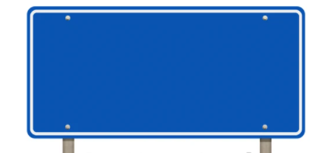

A Level Mathematics is taught through two parallel pathways that run simultaneously across the two years of study. Pathway A focuses on Pure Mathematics and Statistics, while Pathway B focuses on Pure Mathematics and Mechanics. Together, the pathways provide students with a broad and balanced mathematical education.
Y13 Mathematics
Curriculum Pathway A
A Level Mathematics is taught through two parallel pathways that run simultaneously across the two years of study. Pathway A focuses on Pure Mathematics and Statistics, while Pathway B focuses on Pure Mathematics and Mechanics. Together, the pathways provide students with a broad and balanced mathematical education.



P5
Radians

P2
Functions and Graphs

P12
Vectors




P9
Differentiation
P11
Integration

P8
Parametric Equations

P10
Numerical Methods

S3
Normal Distribution

S2
Conditional Probability
S1
Regression

