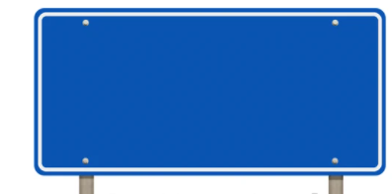
A Level Mathematics is taught through two parallel pathways that run simultaneously across the two years of study. Pathway A focuses on Pure Mathematics and Statistics, while Pathway B focuses on Pure Mathematics and Mechanics. Together, the pathways provide students with a broad and balanced mathematical education.

Y13 Mathematics
Curriculum Pathway B


P6
Trigonometric Functions
P4
Binomial Expansion

P1
Algebraic Methods




P3
Sequences and Series
P7
Trigonometry and Modelling

M4
Moments

M5
Forces and Friction

M7
Application of Forces

M8
Further Kinematics
M6
Projectiles

