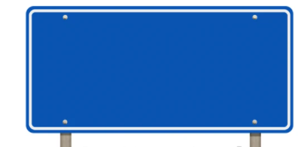

A Level Mathematics is taught through two parallel pathways that run simultaneously across the two years of study. Pathway A focuses on Pure Mathematics and Statistics, while Pathway B focuses on Pure Mathematics and Mechanics. Together, the pathways provide students with a broad and balanced mathematical education.
Y12 Mathematics
Curriculum Pathway A
A Level Mathematics is taught through two parallel pathways that run simultaneously across the two years of study. Pathway A focuses on Pure Mathematics and Statistics, while Pathway B focuses on Pure Mathematics and Mechanics. Together, the pathways provide students with a broad and balanced mathematical education.

P1
Algebra and Functions



P6
Circles

P5
Straight Line Graphs

P3
Equations and Inequalities
S1
Data
Collection



S2
Measures of Location and Spread

S3
Representations of Data
P9
Trigonometry

P10
Trigonometry Identities and Equations

P7
Algebraic Methods

P8
Binomial Expansion

S4
Correlation

S6
Binomial Distribution
S5
Probability

S7
Hypothesis Testing

P14
Exponentials
and Logarithms

