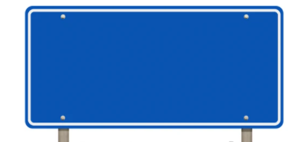
A Level Mathematics is taught through two parallel pathways that run simultaneously across the two years of study. Pathway A focuses on Pure Mathematics and Statistics, while Pathway B focuses on Pure Mathematics and Mechanics. Together, the pathways provide students with a broad and balanced mathematical education.

Y12 Mathematics
Curriculum Pathway B


P4
Graphs and Transformations
P11
Vectors

P2
Quadratics






M8
Modelling

M9
Kinematics

M10
Forces

P13
Integration
P12
Differentiation

M11
Variable Acceleration

