Preparing for OCR A level Business
A-level Business introduces you to all you need to know about the world of business, equipping you with highly sought-after skills that are valued in a wide range of careers and providing a solid foundation for further study or entering the world of work.  You will need to calculate, interpret and analyse a wide range of numerical data relating to finance, operations, marketing and human resources.  This means, you are expected to learn the formulas and perform calculations.  You have to write essays, this means that you will have to write extended answers to questions; this requires attention to spelling and grammar.  You will need to be aware of and understand current business issues and news. This means that you will have read business news and watch the news to know what is going on  You will learn to become a good decision maker, learning essential managerial skills, alongside techniques to help you become an analytical problem solver. | Preparation for September  A list of the main theorists  A list of the formulas  Don't just rely on your lessons for learning.  5 hours independent study is essential for you to get the best grade possible  Useful business news providers such as the BBC, Tutor2u, The Independent, The Guardian, The Econmomist, Sky news provide you with alerts to your phone  TV programmes are useful for application - BBC and Ch4, e.g.Inside the factory, Panorama, Dragons Den  Films to watch:  The Founder  The Social network  The Big Short  The Great Hack  Prodcasts  Mixergy  Outside In  Business wars  Tutor2u  Seneca

Task 1: What is the hidden meaning behind each logo?
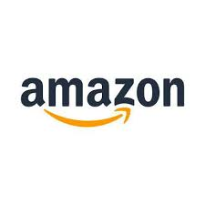 | Everything from A to Z |  | The four-color scheme signifies Google’s ambition to be an innovator, not a brand that does what’s expected. The green color was added as a way to show the audience that Google is a little different, a little more unique than other companies.
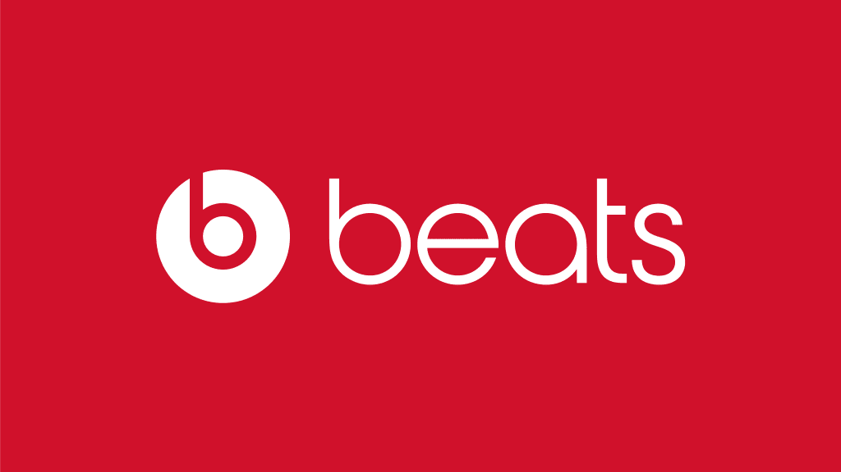 | It actually represents a human's head, and the 'b' letterform represents the brand's headphones. | 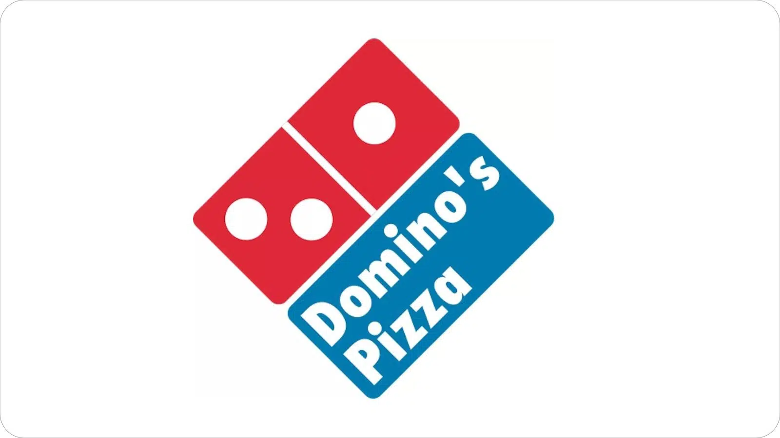 | When Domino’s first opened, the founders didn’t expect the pizza chain to get so huge, and so they intended to add a dot to the dominos in the logo every time a new location opened. The three dots in the logo represent the three original locations.
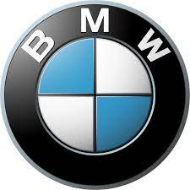 | BMW wanted to use the colours of the Bavarian Free State in their logo, but doing so was illegal, so they reversed the colours and accidentally created the propeller design. |  | Steve Jobs liked the name  The logo is in the shape of an apple because the company is named Apple and the bite mark is only there to give the logo scale—otherwise, people might confuse it for a cherry.
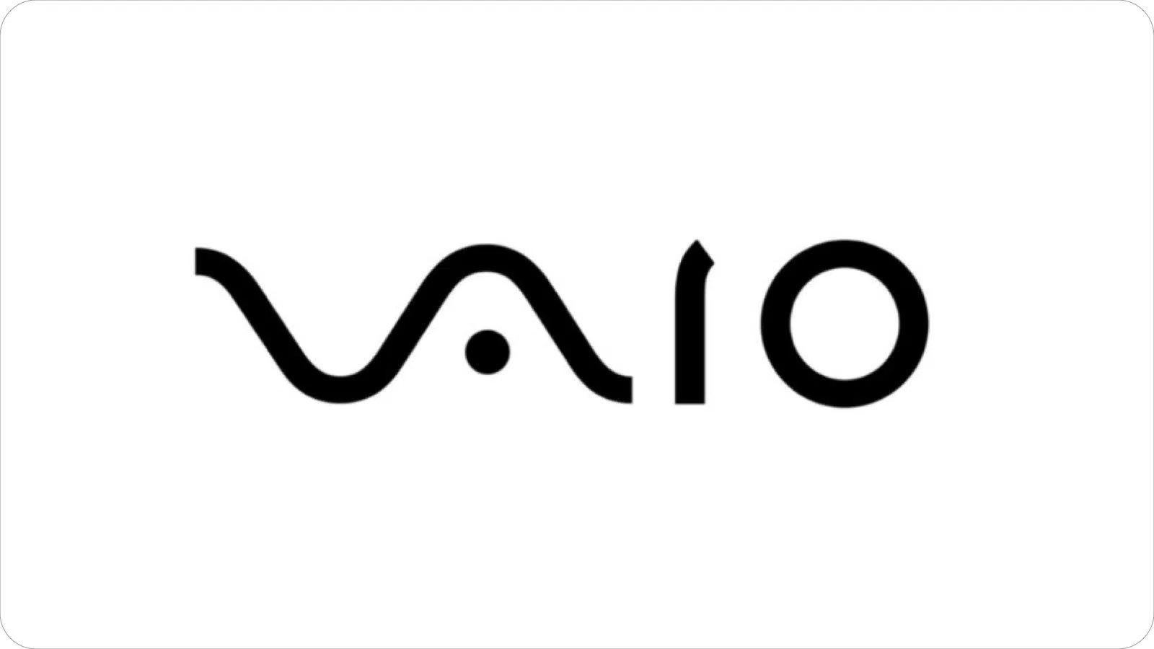 | The ‘V’ and ‘A’ together represent an analog wave, while the ‘I’ and ‘O’ are reminiscent of digital signal (through the binary numbers 1 and 0). | 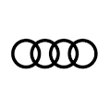 | Each ring of the logo represents an arm of auto union, with the overlapping circles showing their partnership
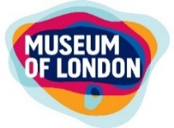 | Represents the geographical area of London and its neighborhoods as they grew outwards over time. | 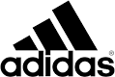 | Represent the struggle athletes must endure to achieve greatness.

Task 2: "There is no perfect business decision."
Why do intelligent business leaders make different decisions when looking at the same evidence?
Reason 1 | Reason 2 | Reason 3

Task 3: Scenario 1: The Coffee Shop Dilemma
Current Situation  New costs mean profits are falling. | Options
  Item | Value
  Daily customers | 250
  Coffee price | £3
  Last year profit | £45,000
  Option | Description | Rank the options in order of priority and explain why
  A | Increase prices by 20%
  B | Keep prices the same
  C | Reduce staff hours

Decision Grid
Question | Your Answer
Which option would you choose?
Who benefits?
Who loses?
What risks exist?
Why is your option best?

The New Product Launch  Investment: £200,000 | Additional Evidence  - Research team: Product B could become very popular  - Finance manager: Product B could lose money  - Marketing manager: Product A is easiest to sell
  Product | Description
  A | High demand, many competitors
  B | Unique idea, uncertain demand
  C | Moderate demand, moderate risk
Recommendation Grid |  | Challenge  If your decision fails, what could happen?
  Question | Your Answer
  Which product will you choose?
  Why (risk)?
  Why (reward)?
  What is uncertain?

The Ethical Problem  Situation  A cheaper supplier offers 30% lower costs but has poor working conditions and low wages. | Stakeholder Views  - Customers: want low prices  - Employees: want ethical behaviour  - Investors: want higher profits
Decision | Explanation Grid
  Option | Tick (✔)
  - Use the supplier
  - Reject the supplier
  - Use temporarily while finding alternatives
  Question | Your Answer
  Why did you choose this option?
  Who benefits?
  Who is harmed?
  Why might others disagree?

Expansion or Survival?  Situation  A business has £1 million.  Options | Economic Forecast  Experts disagree:  - Some predict growth  - Some predict recession
  Option | Description
  A | Open five new stores
  B | Invest in technology
  C | Keep money for future problems

Recommendation Grid
Question | Your Answer
Which option do you choose?
What are the risks?
What are the opportunities?
What information would help you decide?

Task 4: Economy
What does inflation mean?  How is the UK inflation rate measured? |  | What is the virtual “basket of goods”

Why are prices still rising? | Why does putting up interest rates help to lower inflation?

Task 4: Learn these formulas. You will be tested on these in the first week and through your course
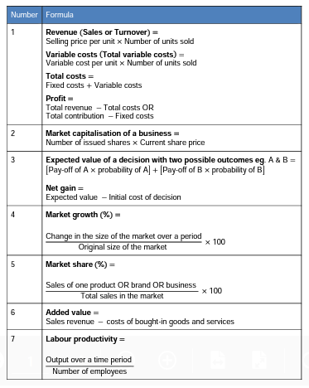 | 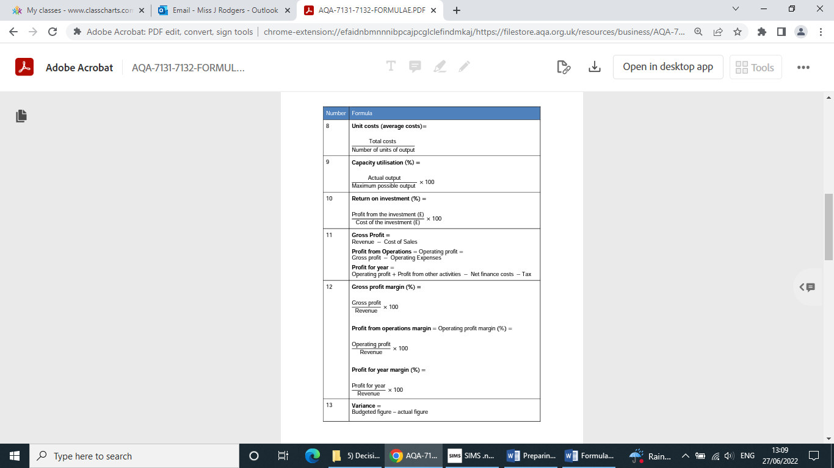
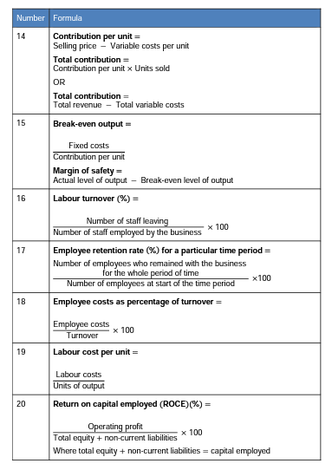 | 