Keywords  Outlier – a value that stands apart from the rest of the data | 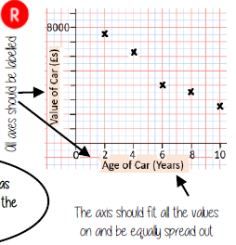  Basics: | Example  Describe the relationship: As the age of the car increases, the value of the car decreases  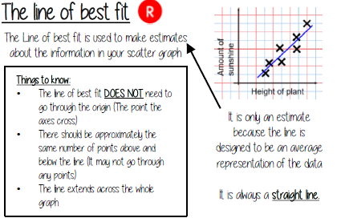  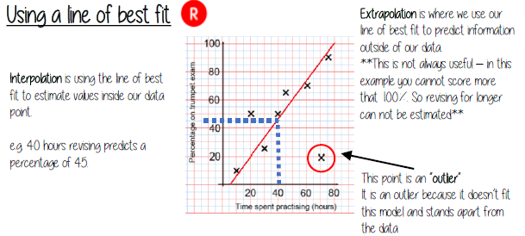
Key Facts
