Keywords  Rotation - Rotation has a central point that stays fixed and everything else moves around that point in a circle.  Translation - Every point of the shape together move: the same distance, in the same direction.  Reflection – Produces a mirror image of the shape across a line  Enlargement – Make a shape larger or smaller  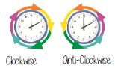 | 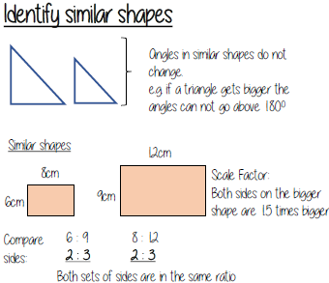 | Examples  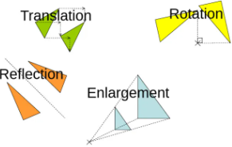  Transformations  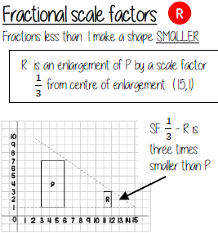  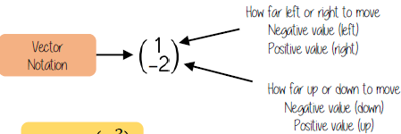  Translation notation
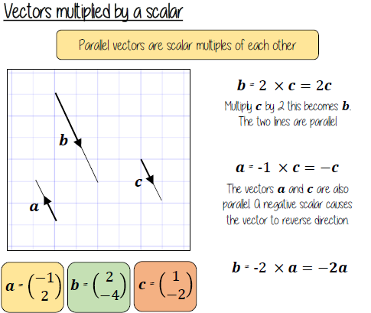
Key Facts
