Keywords  Inequality – an inequality compares who values showing if one is greater than, less than or equal to another.  Simultaneous Equations– Two or more equations that share the same solutions.  Iteration - Repeating a process. Sometimes a question can be answered by getting closer and closer using the same process each time. |     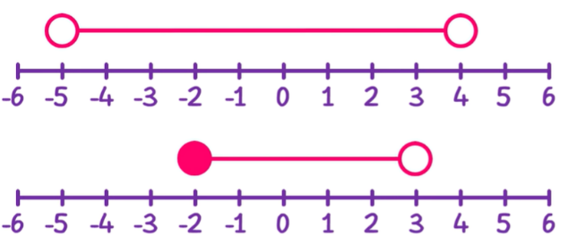  Key Facts  Inequalities can be drawn on number lines. |   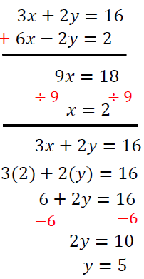  Examples  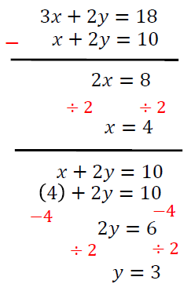  Sign  Same  Subtract  Sign  Different  Add  You may need to multiply first to get a coefficient the same  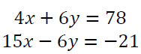  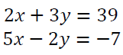  x 2  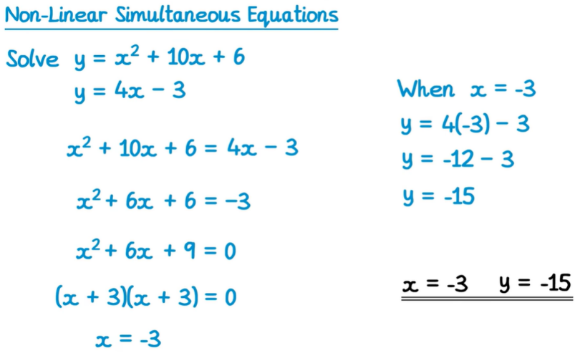  x 3
Examples - Inequalities
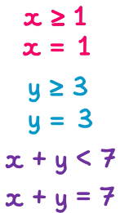
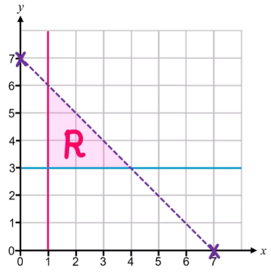
Linear inequalities
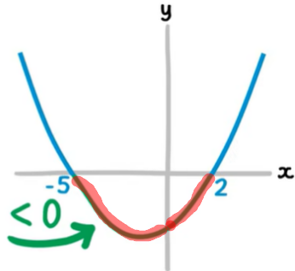
Quadratic inequalities (example)
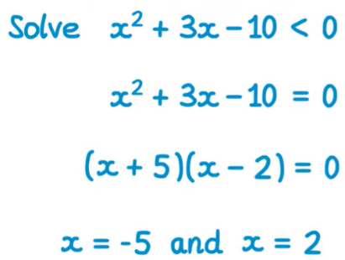

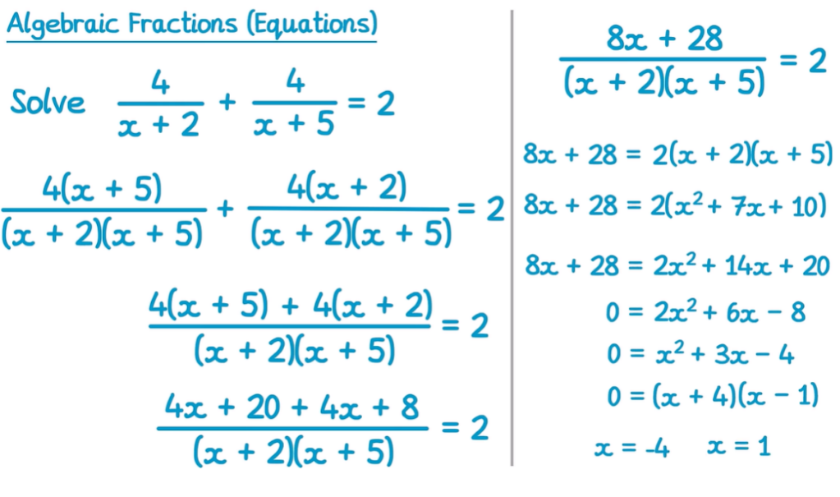

Iteration
- Enter the initial value (x₀): Type your starting value into the calculator and press the equals (=) button to store it in the answer memory
- Enter the iterative formula: Type the right-hand side of your iterative formula into the calculator, replacing the (x_{n}) term with the ‘Ans button’.
- Generate the first iteration (x₁): Press the equals (=) button once to calculate the first estimate, (x₁). Calculator's answer memory now holds this new value.
- Generate subsequent iterations (x_{2,} x_{3,} etc.): Press the equals (=) button again

