Keywords  Bearing – The angle in degrees measured clockwise from north, must be 3-figures (e.g 70º becomes 070º)  Perpendicular – where two lines meet at 90º (right-angles)  Scale – the ratio of the length of a drawing to the length of the real thing | Formulae  $$Speed=\frac{Distance}{Time}$$  $$Density=\frac{Mass}{Volume}$$  $$Pressure=\frac{Force}{Area}$$ | 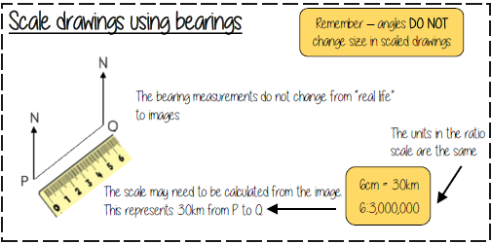  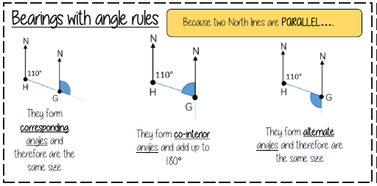  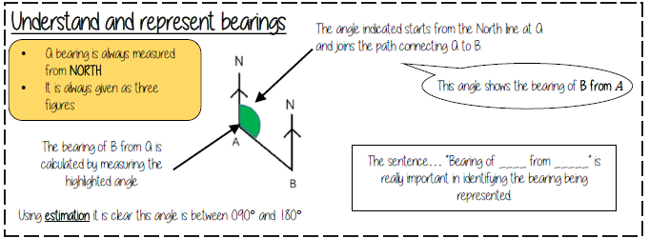  Examples – Bearings  Bearings – continued  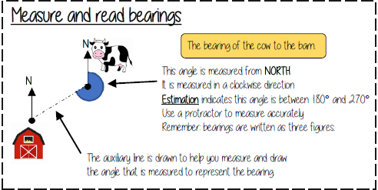  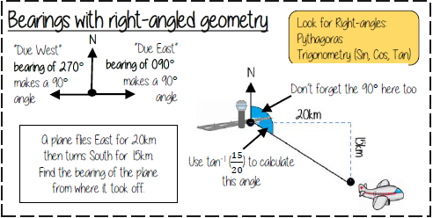
Key Facts
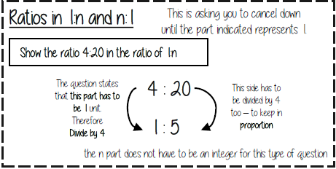
Scale Drawings: 1:20 means for every 1cm on the model there are 20cm in real life (Remember: Scale drawings ONLY change lengths and distance; ANGLES remain the same

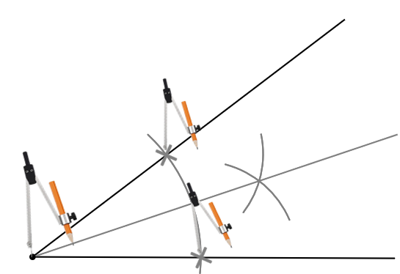
Perpendicular Bisector Angle Bisector
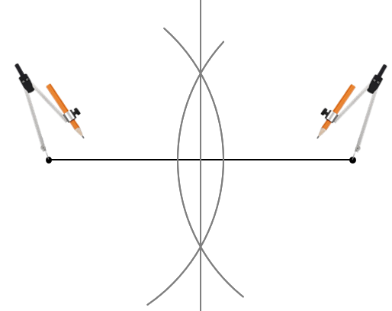

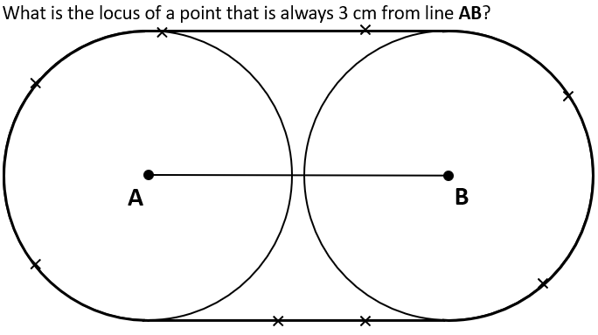
Loci

