Keywords  Equivalent – has the same value  Mixed number - a number with an integer and a proper fraction  Improper fraction - a fraction with a bigger numerator than denominator  Reciprocal - a pair of numbers that multiply together to give 1  Terminating decimal - decimal number that has digits which end e.g. 0.25  Recurring decimal - decimal number with a digit (or group of digits) that repeats forever e.g 0.6666 or $0.\dot{1}2\dot{5}$ | 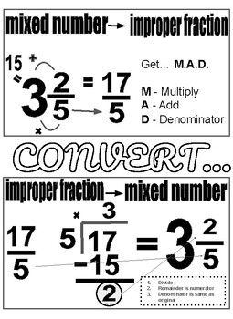  Formulae | 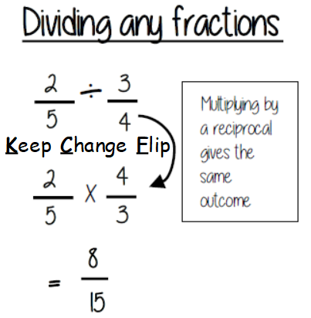  Examples  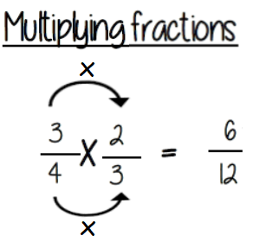  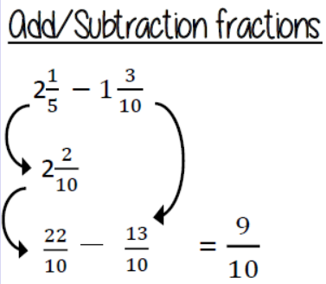  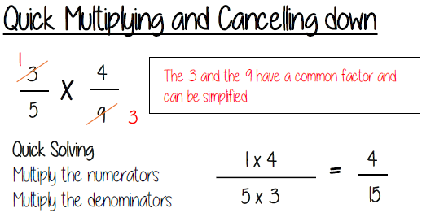  common denominator  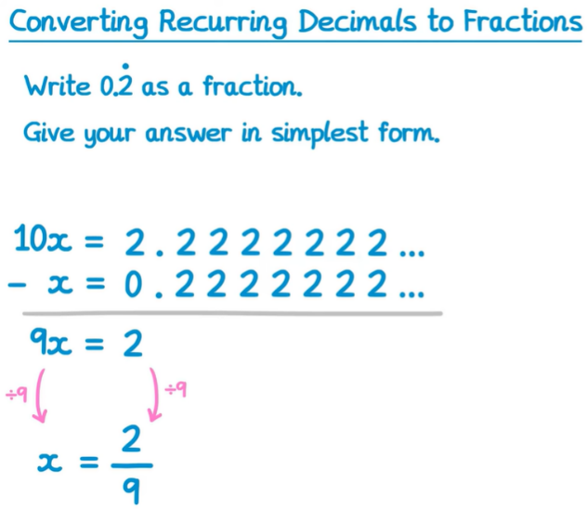  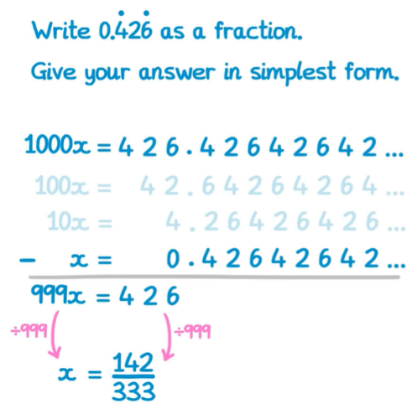  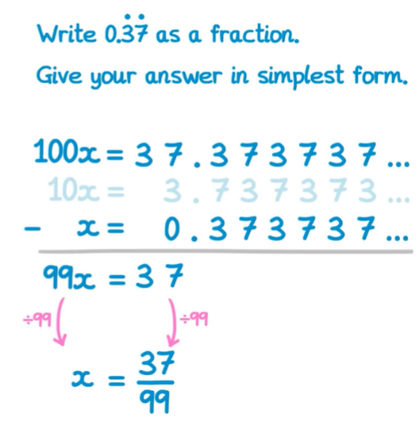
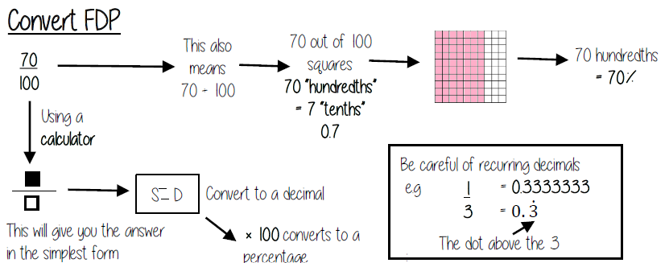
Key Facts

