Keywords  Exact value – This means leave your answer as it appears on your calculator (or as far as you can get without a calculator), which usually means leave your answer as a surd | Formulae (need to know)  Pythagoras’ Theorem:  $$a^{2}+b^{2}=c^{2}$$  Trigonometry:  $$\sin\left(θ\right)=\frac{O}{H}$$  $$\cos\left(θ\right)=\frac{A}{H}$$  $$\tan\left(θ\right)=\frac{O}{A}$$ | 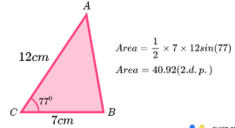  Examples  Area of Triangle:  Sine Rule: Find side ‘$x$’ to 1 dp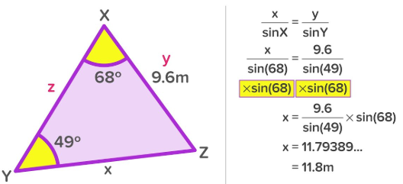  Find angle$x$ to 2 dp  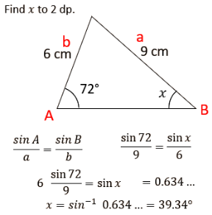
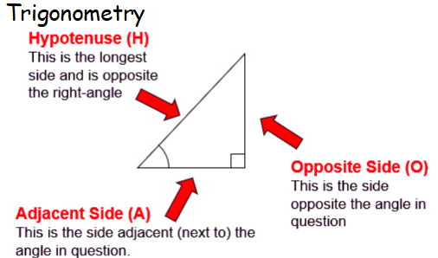
Key Facts
Exact Trig Values:
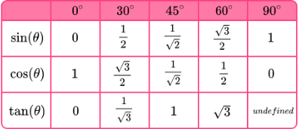

Formulas: (Need to know how to use but given the formula)
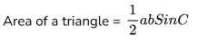
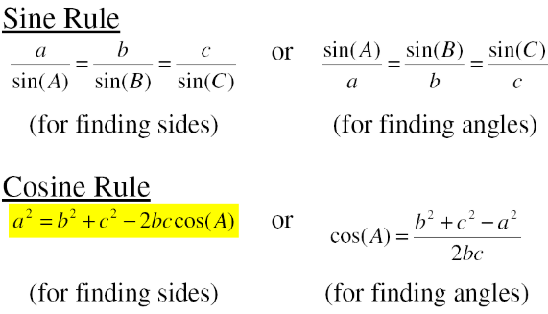

Examples (Continued)
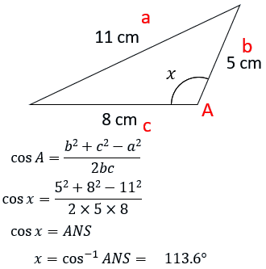
Cosine Rule: a) Find the length of x to 1 dp b) Find the size of angle x to 1 dp
