Keywords  Quadratic – a curved graph with the highest power being 2 (square power)  Reciprocal – a reciprocal is 1 divided by the number  Cubic - a curved graph with the highest power being 3 (cube power)  Parabola – a ‘U’ shaped curve that has mirroring symmetry | Formulae  Linear graph: $y=mx+c$  Quadratic graph:  ${y=ax}^{2}=bx+c$ | Examples:  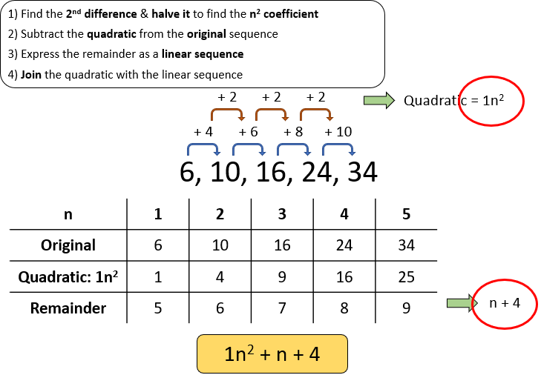  Quadratic Nth Term  Iterations with Sequences:  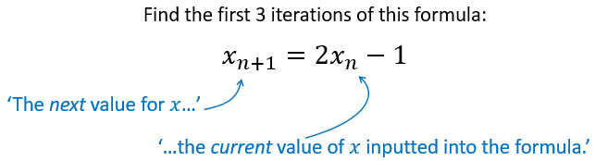  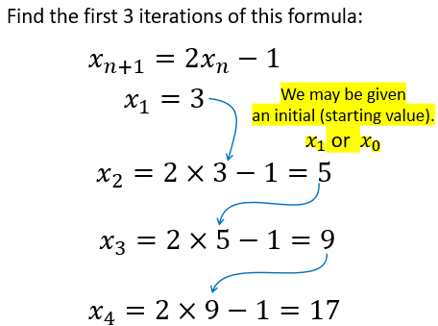  Complete the square to calculate turning point of  ${y=x}^{2}+4x-6$  $${y=(x+2)}^{2}-{(2)}^{2}-6$$  ${y=(x+2)}^{2}-10$ Turning point: (-2, -10)  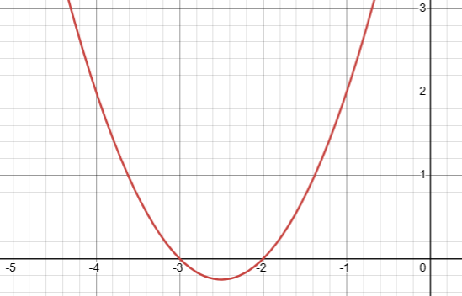  Interpreting Quadratic Graphs: ${y=x}^{2}+5x+6$  $Roots: x = -2, x = -3$  y-intercept: (0, 6)  Turning point: (-2.5, -0.25)  - x value needs to be -2.5 (half way between 2 roots)  - work out y value for turning point by substituting x = -2.5 into the original equation  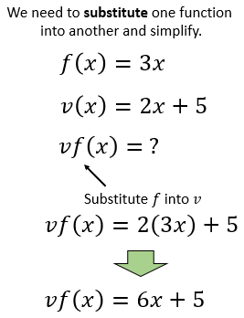  Composite functions:
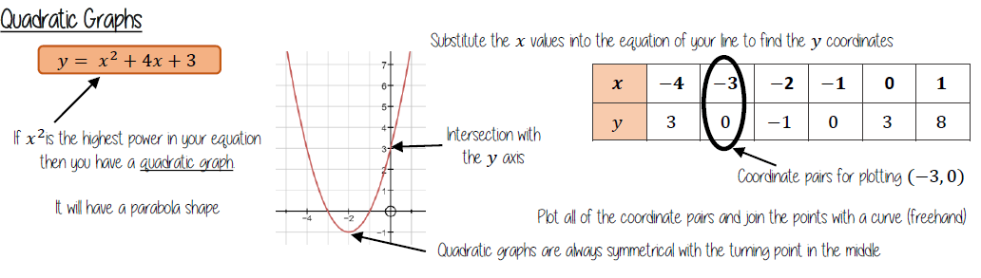
Key Facts

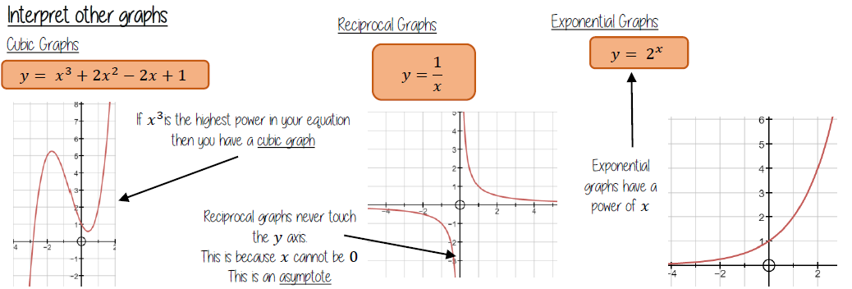

Examples: Length of a line segment
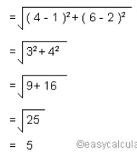
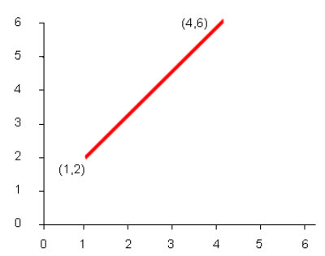

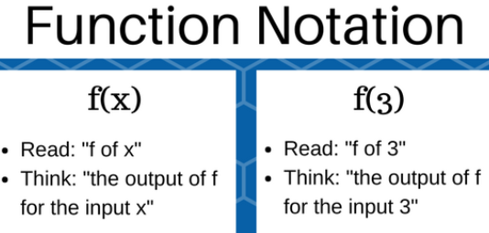
Inverse functions:
