Keywords  Arithmetic Sequence: Change by common difference. This is found by addition or subtraction between terms  Geometric Sequences: Change by a common ratio. This is found by multiplication/ division between terms  Term to term rule: How you get from one term, to the next term  Position to term rule: Take the rule and substitute in a position to find a term e.g. multiply the position by 3 and then add 2  Fibonacci sequence: each term is the sum of the previous two terms  Sequences: Repetition of a pattern  Parallel lines: Lines on a plane that never meet. They are always the same distance apart e.g. train tracks.  Perpendicular Lines: Lines that are at right angles (90°) to each other.  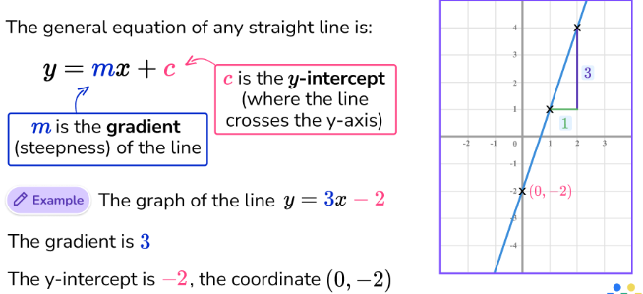 | Examples  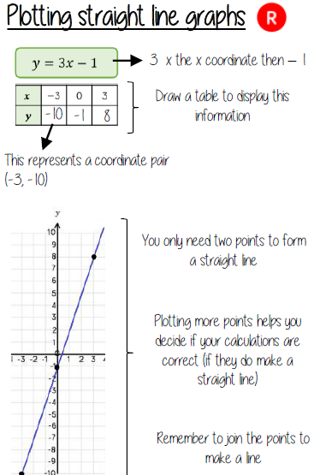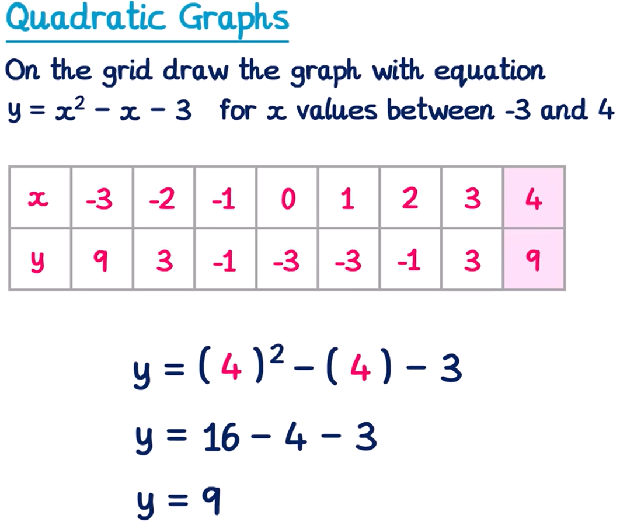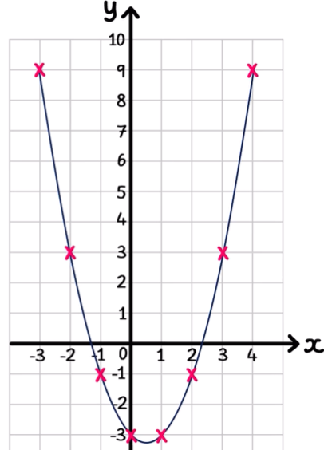 | Examples  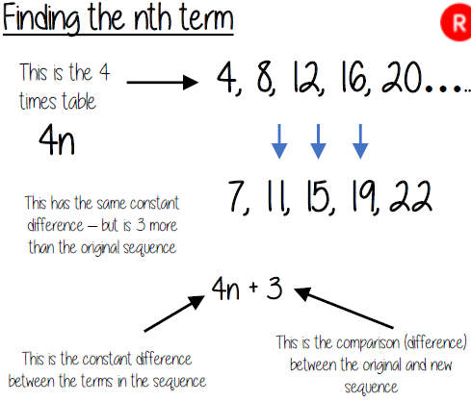  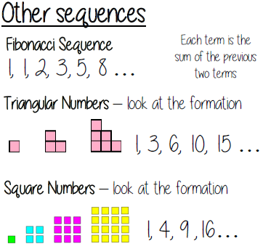
Key Facts

