Keywords  Event: one or more outcomes from an experiment  Outcome: the result of an experiment  Intersection: element (parts) that are common to both sets  Union: the combination of elements in two sets  Expected Value: the value/outcome that a prediction would suggest you will get  Universal set: the set that has all the elements  Product: the answer when two or more values are multiplied together | 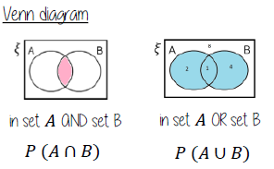  Formulae  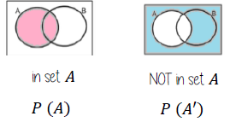 | 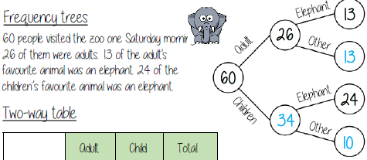  Examples  Independent Events  The outcome of two events happening. The outcome of the first event has no bearing on the outcome of the other.  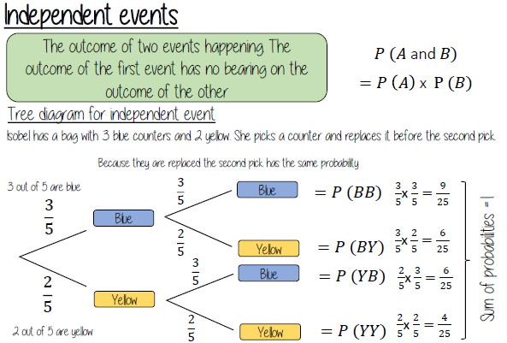  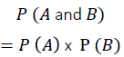
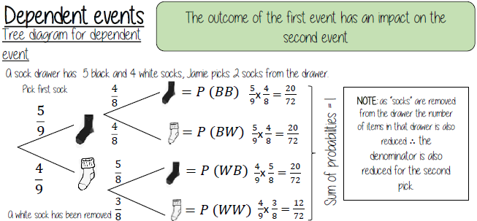
Example (Dependent/Conditional Events)

