Keywords  Equation - An equation says that two things are equal and will contain an "="  Inequality – an inequality compares who values showing if one is greater than, less than or equal to another. < > ≤ ≥  Simultaneous Equations– Two or more equations that share the same solutions.  Solve - find a value (or values) we can put in place of a variable that makes the equation true. | 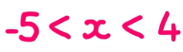  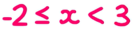  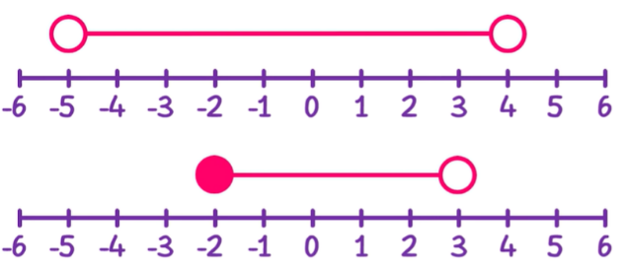  Key Facts  Inequalities can be drawn on number lines.  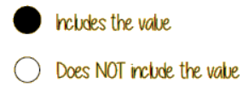 | 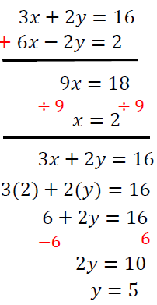  Examples    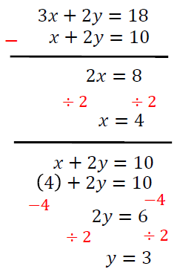  Sign  Same  Subtract  Sign  Different  Add  You may need to multiply first to get a coefficient the same  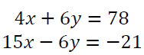  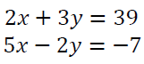  x 2  x 3
Examples – Solving equations and inequalities
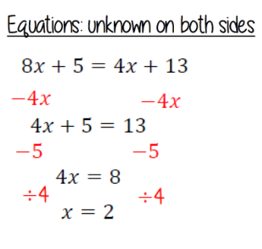
Solving Inequalities
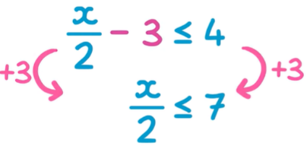
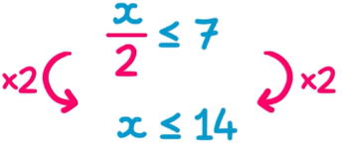
Equations
