Keywords  Continuous Data: Data that can be measured (e.g height, time)  Histogram: is a graphical chart used to display the distribution of continuous numerical data  Cumulative Frequency: displays a running total of frequencies, visually representing how data accumulates over a range.  Box plot: is a standardized way of displaying the distribution of data based on a five-number summary: the minimum, lower quartile, median, upper quartile, and maximum. | Formulae  For histograms:  Frequency Density  $= \frac{Frequency}{Class width}$  Frequency = Area of bar | Examples: Cumulative Frequency Graphs  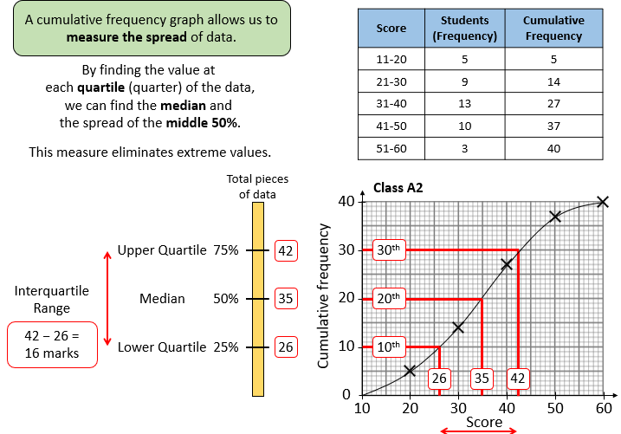  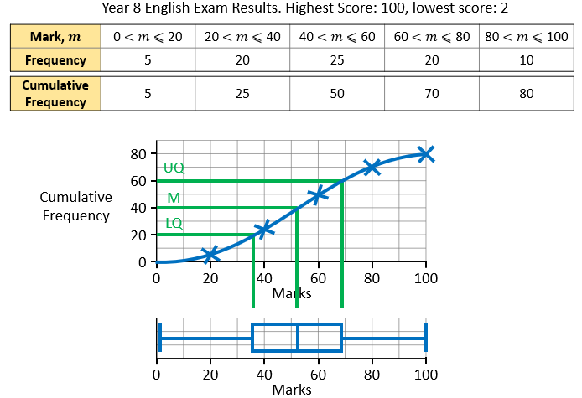  You can use cumulative frequency graphs to draw box plots  Using Histograms to work out data:
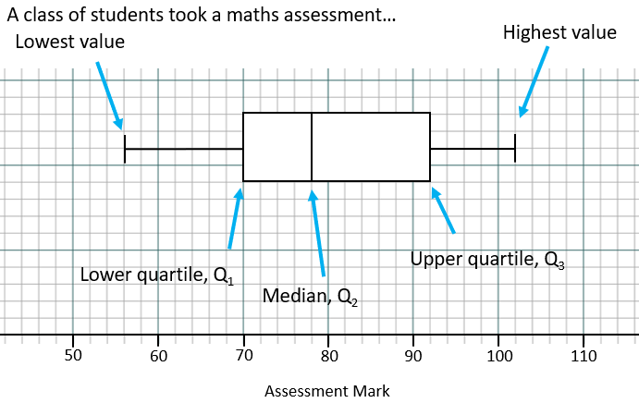
Examples: Box Plot
Information you can find from a box plot:
Lowest value: 56
Lower Quartile: 70
Median: 78
Upper Quartile: 92
Highest Value: 102

Range: 102 – 56 = 46
Inter-quartile range: UQ – LQ = 92 – 70 = 22

Histograms:
