Keywords  Transformation: a function that manipulates a geometric shape, point, or mathematical expression, altering its position, size, or orientation  Rotation: "Turning" an object around a specific central fixed point by a certain degree and direction.  Enlargement: to change the size of the shape (this can be bigger or smaller)  Translation: Where a shape’s position is moved (either left/right/up/down) but the shape must stay the same size  Reflection: "Flipping" an object across a specified line of reflection (like a mirror), creating a mirror image  Symmetry: When two or more parts are identical after a transformation  Scale factor: The multiple describing how much a shape has been enlarged  Similar Shapes: Shapes of different sizes that have corresponding sides un equal proportion & identical corresponding angles | 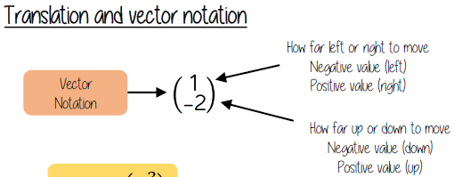  Examples  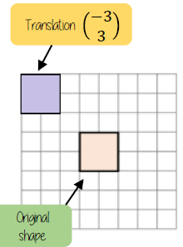    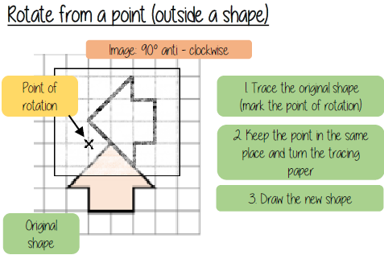  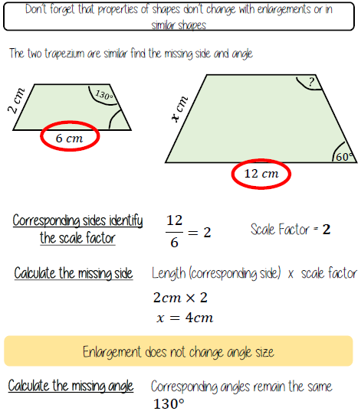  Similar shapes  Reflection: Reflect triangle ABC in the line $y=x$  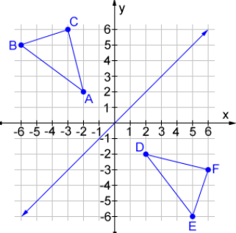
Key Facts
Enlargement (Positive fractional scale factor)
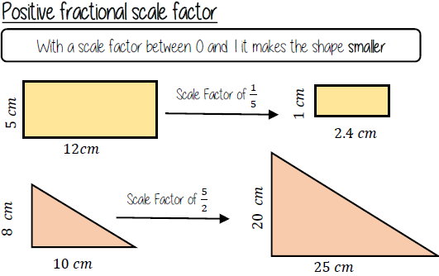

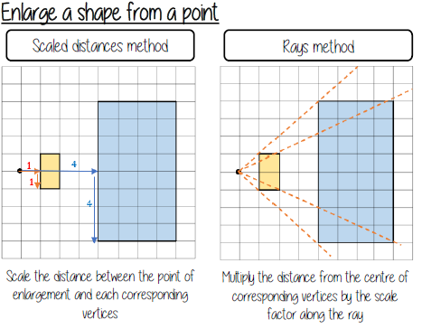

Negative Enlargement
Enlarge triangle ABC by a scale factor of –½, centre (0, 2)
