 | Formulae  Area of a triangle = (base x height) / 2  Area of a trapezium = (a + b) x h x ½  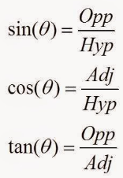  Area of a square = base x height  Area of a rectangle = base x height  Area of a circle = $π ×{(radius)}^{2}$  Area of a sector = (angle/360) x $π ×{(radius)}^{2}$  Circumference of a circle = $π×diameter$  Arc Length = (angle/ 360) x $π×diameter$  Pythagoras = $a^{2}+b^{2}= c^{2}$  Perimeter = The outside of the shape  Area = The inside of the shape | 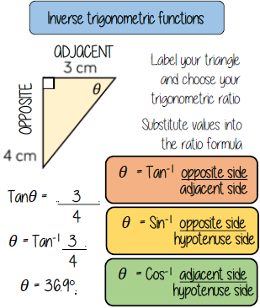  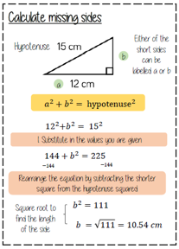  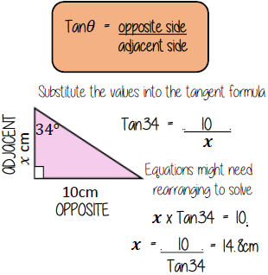  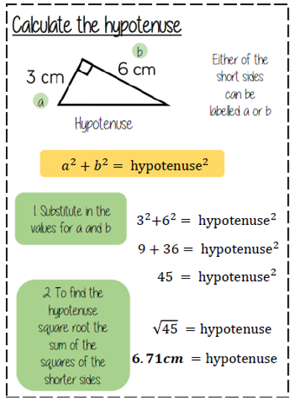  Examples
Key Facts
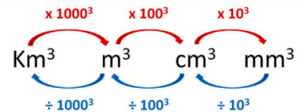
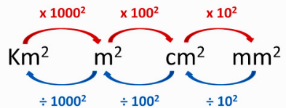
Converting area Converting volume
Converting length

