Keywords  Expression – Numbers, symbols and operators put together to represent a value, does not have an = sign  Factorise – Find what to multiply to get an expression, putting something into brackets  Substitute – Putting values where the letters (variables) are  Expand – When we multiply to remove the ( )  Coefficient – A number used to multiply a variable e.g. the 4 in 4x  Rearrange – use inverse operations to change the subject  Subject – The variable that is isolated on one side of the formula | Examples  Multiple out Single Brackets 3(2x + 4)  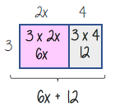 | Examples  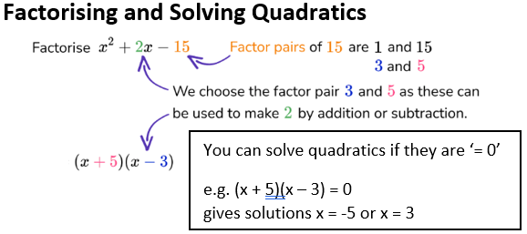  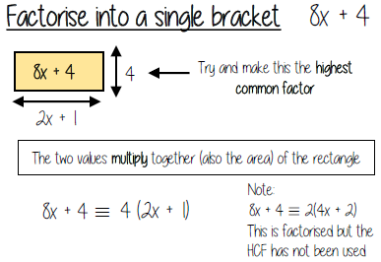
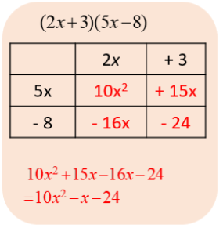
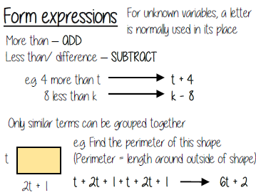
Expanding Double Brackets

