Keywords  Frustum: A frustum is a geometric 3D shape created by slicing the top off a cone or pyramid with a plane parallel to its base | Formulae  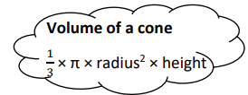  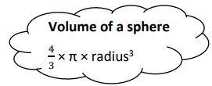  Volume of pyramid:  Perpendicular height  Area of base  $\frac{1}{3}× ×$ | 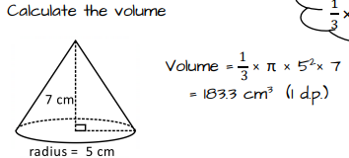  Examples  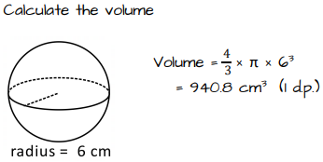  Volume of Frustum:  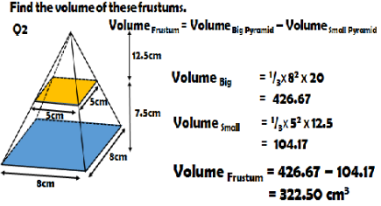
Examples
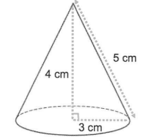
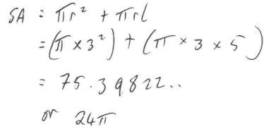
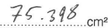
Surface Area of Sphere Surface area of Cone
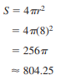
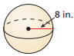
in²

Surface Area of hemisphere
