Keywords  Equivalent – has the same value  Simplify – make a fraction as simple as possible (by dividing numerator and denominator by the same numbers).  Mixed number - a number with an integer and a proper fraction  Improper fraction - a fraction with a bigger numerator than denominator  Reciprocal - a pair of numbers that multiply together to give 1 | 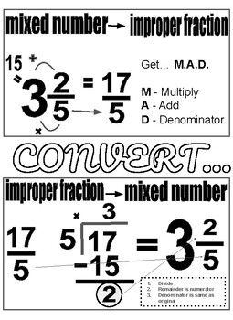  Formulae | 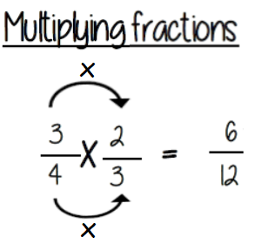  Examples  SIMPLIFYING  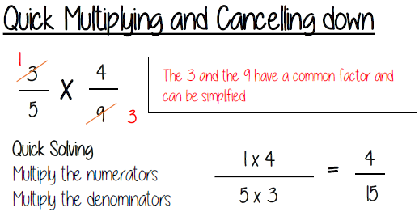  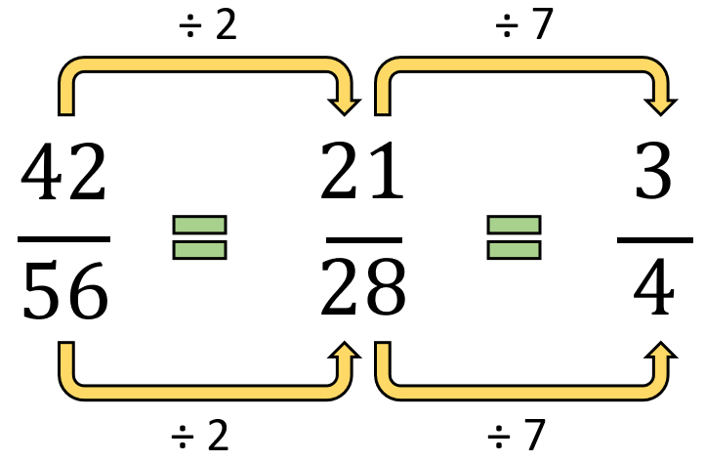  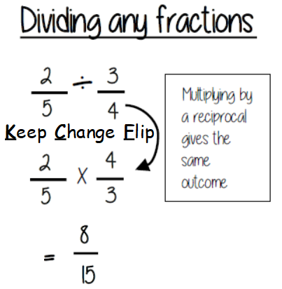  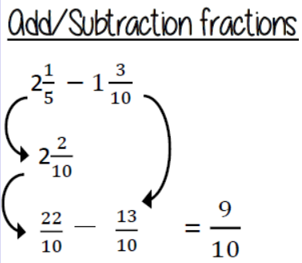  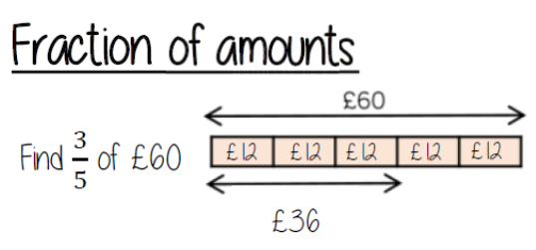  common denominator  Divide by the denominator 60 ÷ 5 = 12  Multiply by the numerator 12 x 3 = 36
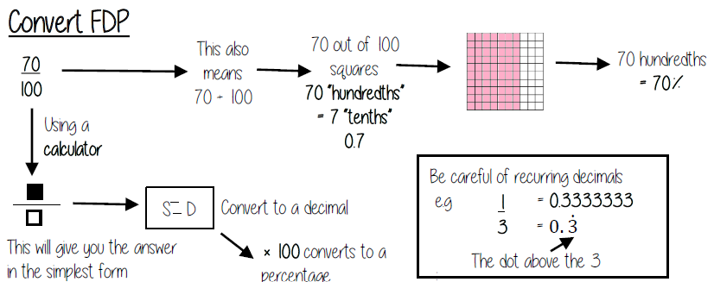
Key Facts

