Keywords  Compound Interest – Calculating interest on both the amount plus previous interest  Depreciation – a decrease in the value of something over time  Growth - where a value increases in proportion to its current value, such as doubling  Multiplier – the number you are multiplying by  Examples  Compound Interest:  Multiplier: 1.003 (from 1 + 0.003)  Depreciation:  Multiplier: 0.78 (from 1 - 0.22)  $A=399×{0.78}^{2}$ $A=£242.75$ | Formulae  Percentage change =  $\frac{change }{ariginal amount}×100$  Compound interest/ depreciation:  $$Amount×{multiplier}^{n}$$  (n = number of years)  Reverse Percentages/  Original amount:  $$Final value ÷multiplier$$  Direct proportion:  $$y∝x y=kx$$  Inverse Proportion:  $$y∝\frac{1}{x} y=\frac{k}{x}$$ | Examples  Reverse Percentages:  Multiplier: 1.12 (from 1 + 0.12)  $$Original amount ×1.12=728$$  Original amount = 728 ÷ 1.12 = 650 fans  Direct Proportion:  Step 1: Write an equation using k  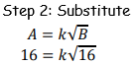  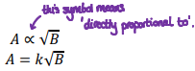  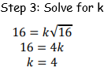  Step 4: A in terms of B  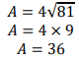  Step 5: Find A  Inverse Proportion: Steps are the same as direct proportion but use  $$y∝\frac{1}{x} y=\frac{k}{x}$$
Examples – Combining ratios Sharing in a ratio – given 1 part
