Keywords  Probability – the likelihood of an event occurring, measured on a scale from 0 (impossible) to 1 (certain).  Event – an outcome or set of outcomes from a random experiment.  Independent – when the outcome of one event does not affect the probability of another. | Formulae  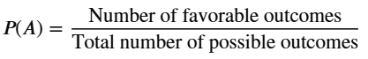  Sum of probabilities of all possible outcomes = 1  P(not happening) = 1 – P(happening) | Examples  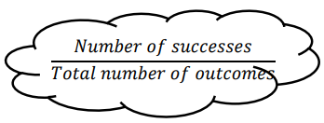  Theoretical Probability  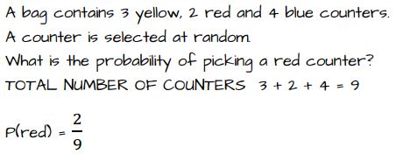  Sample Space Diagrams  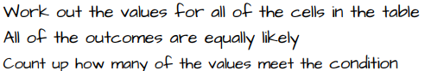  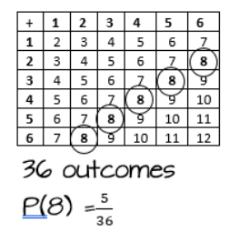
Key Facts
Probabilities can be written as a fraction, decimal, or percentage.
Probabilities are ALWAYS between 0 and 1.
Theoretical probability is what is expected to happen based on mathematical calculations and logic, calculated as the number of favourable outcomes divided by total possible outcomes.
Experimental probability is what actually happens when you conduct a real-world test or trial, calculated by dividing the observed number of times an event occurs by the total number of trials.
