Keywords  Compound interest – calculating interest on both the amount plus the previous interest  Depreciation – a decrease in the value of something over time  Multiplier – The number you are multiplying by | Formulae  Percentage change =  $\frac{change }{ariginal amount}×100$  Compound interest/ depreciation:  $$Amount×{multiplier}^{n}$$  (n = number of years)  Reverse Percentages/  Original amount:  $$Final value ÷multiplier$$ | Examples  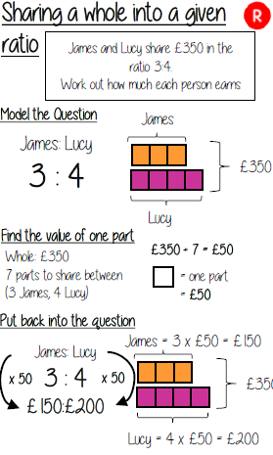  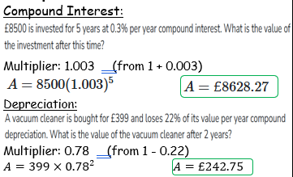
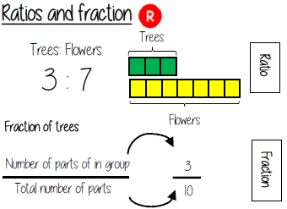
Key Facts
