

**GCSE Geography Revision Booklet**

**Paper 1: Living with the physical environment**

**Length of exam: 55 MINUTES**

**FOR THE 2025 MOCK YOU WILL ONLY BE TESTED ON THE FOLLOWING TWO TOPICS:**

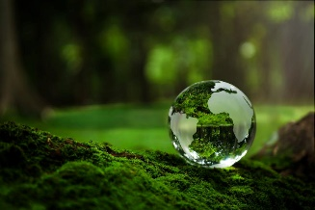**Section B: The Living World**

* Ecosystems
* Tropical Rainforests
* OPTION: COLD ENVIRONMENTS

**Section C: Physical landscapes in the UK**

* 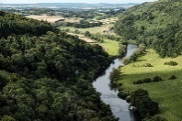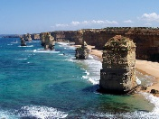OPTION 1: COASTAL LANDSCAPES
* OPTION 2: RIVER LANDSCAPES

**Preparation for Y11 mock 2 exams February-March 2025**

* **Name: …………………………………………………………………….**

**Section B: The Living World**

**Ecosystems exist at a range of scales and involve the interaction between biotic and abiotic components**

**What is an ecosystem?**

An ecosystem is a natural environment and includes the flora (plants) and fauna (animals) that live and interact within that environment. Flora, fauna and bacteria are the biotic or living components of the ecosystem.

* Producers - Convert energy from the environment (mainly sunlight) into sugars (glucose). The most obvious producers are plants that convert energy from the sun by photosynthesis.
* Consumers - Get energy from the sugars produced by the producers. A pond snail is a good example of a consumer because it eats plants.
* Food chain - This shows the direct links between producers and consumers in the form of a simple line.
* 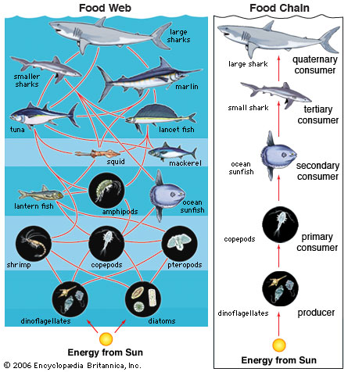Food web - This shows all of the connections between producers and consumers in a rather more complex way.

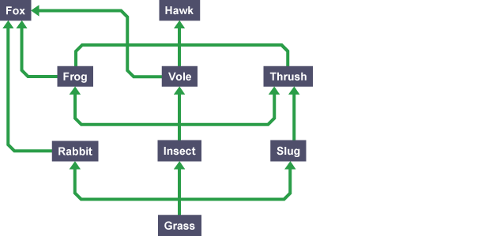

When all the food chains in an ecosystem are joined up together, they form a food web. Here is an example of a food web:

**What are trophic levels?**

The stages in a food chain or web are called trophic levels. The arrows show the transfer of biomass (living or recently dead tissues) from one trophic level to another.

A simple food chain:

* algae → mosquito larvae → dragon fly larvae → perch

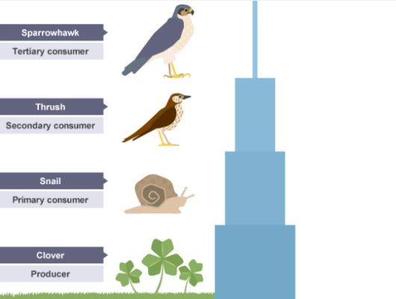An example of a pyramids of biomass:

Not all of the biomass is passed from the maize plants to the locusts. In fact, only about ten per cent of the biomass is transferred from each trophic level to the next. The remaining 90 per cent is used by the trophic level to complete life processes. Biomass can be lost between stages because not all of the matter eaten by an organism is digested. Some of it is excreted as waste such as solid faeces, carbon dioxide and water in respiration and water and urea in urine.

Because only around 10% of the biomass at each trophic level is passed to the next, the total amount becomes very small after only a few levels. So, food chains are rarely longer than six trophic levels.

**Characteristics of biomes**

* Tropical rainforest - found near the Equator. The climate is hot and humid and many different species can be found here.

**Tropical rainforest ecosystems have a range of distinctive characteristics**

**Deforestation has economic and environmental impacts**

Deforestation is the large-scale destruction of trees.

**What are the impacts of deforestation?**

**Soil erosion**

Once the land is cleared of **rainforest vegetation** the soil is left bare. When it rains, the nutrients in the soil are washed away. The nutrient cycle stops because there are no plants or trees shedding leaves to replace the nutrients in the soil. The soil is no longer able to support plant life because it is **not fertile**. The roots of plants and trees no longer hold the soil together so it is easily eroded.

**Cold environments (polar and tundra) have a range of distinctive characteristics**

Cold environments experience temperatures that are at or below zero degrees Celsius for long periods of time. Two types of cold environment are polar and tundra.

**Polar**

Characteristics of polar areas include:

* **Climate** - long cold winters, with annual temperatures mostly below freezing. Polar areas are often windy, with very little precipitation. Permanent ice caps cover polar landscapes.
* **Soil** - the soil is covered in ice throughout the year.
* **Plants** - hundreds of species of moss, algae and lichen survive the harsh conditions of the Polar biome. Few other plants can survive.
* **Animals** - Polar bears live in the Arctic and penguins live in the Antarctic. Whales, seals and snowy owls are also found in Polar Regions.

|  |
| --- |
| **Polar bears have adapted to live in polar environments in the following ways:** |
| * They have thick fur and a layer of blubber to keep them warm * Their fur is hollow and transparent. It reflects visible light and looks white, reflecting the snow. * Their skin is black, this helps absorb heat * They have small ears to reduce heat loss * They have a layer of blubber which forms over the summer and use it as an energy store in the winter * They have stiff hairs on their paws to help with swimming, traction and insulation * They have front paws that are webbed to help with swimming * They have a greasy coat that sheds water after swimming - to help reduce heat loss * They have large feet with bumps on called papillae to distribute their load and increase grip on the ice |

How have animals adapted to the physical conditions of these cold environments? Give four examples in the table below:

|  |  |  |
| --- | --- | --- |
| **Animal** | **Adaptation** | **How does it help it to survive? Link to climate** |
| Polar bear | 1. |  |
| 2. |  |
| 3. |  |

**Plant adaptations in cold environments**

* **Cushion plants** - these are compact, low growing plants. These characteristics help them to survive in cold and windy conditions. They trap airborne dust and use it as a source of nutrients.
* **Arctic poppy** - this has a hairy stem to retain heat. The flower can track the sun in the sky to maximise the amount of sunlight it receives so that it can increase **photosynthesis.**
* **Cotton grass** - this grass has small seeds that can easily be dispersed by the wind to ensure its survival. It is low lying to protect it from cold winds and has thin leaves to reduce water loss by **transpiration.** It grows and produces seeds quickly as soon as the temperature increases.
* **Lichen** - this organism does not need soil to grow; it can survive on bare rock. It grows very slowly, can withstand very cold temperatures and survives beneath snow.

Some general adaptations of plants in cold environments include;

* Soils are often waterlogged because of the permafrost underneath, hardy plants like moss can cope with seasonal drought and waterlogging.
* Some plants in the biome have a wax type of fuzzy, hairy coating on them which helps to shield them from the cold and the wind. This coating also helps them to retain heat and moisture and it protects he plant seeds to allow for reproduction.
* They have small leaves which helps the plants to retain moisture. Only the top layer of soil thaws out in the Tundra, below that is the permafrost, therefore the plants have very shallow root systems.
* The low amounts of light pose problems for plants. Most of the plants in the Tundra Biome are perennials and don’t die off in the winter, they have long life cycles to help with the short growing season. This means photosynthesis can begin immediately once the sunlight is strong enough as plants don’t need to regrow leaves.  Some plants like arctic poppy flower quickly, even whilst the snow is still melting.  They also have cup shaped flowers that face the sun to capture as much insolation as possible.

|  |  |  |
| --- | --- | --- |
| **Plant** | **Adaptation** | **How does it help it to survive? Link to climate ad soil** |
| Cushion plants |  |  |
| Arctic poppy |  |  |
| Cotton grass |  |  |
| Lichen |  |  |

**Development of cold environments creates opportunities and challenges**

CASE STUDY: A cold environment: Svalbard

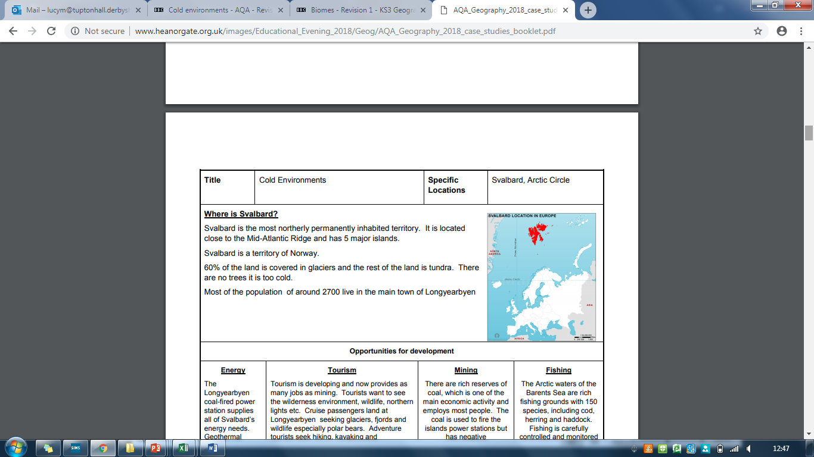

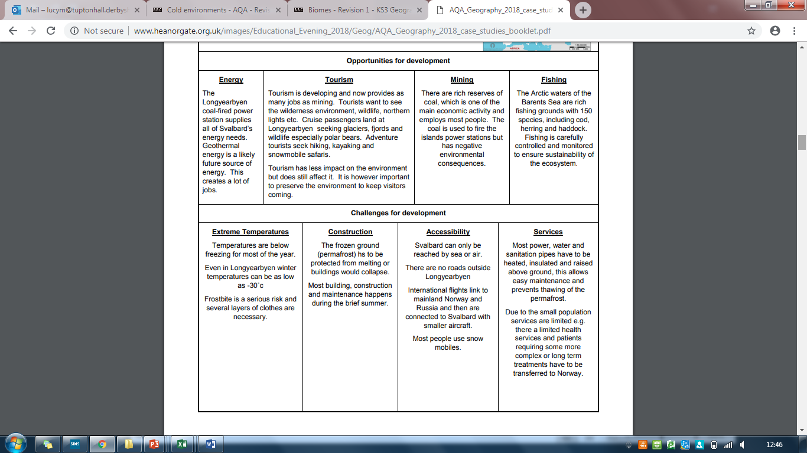

**Cold environments are at risk from economic development**

# **Managing the risks facing cold environments**

Cold environments provide one of the last wilderness areas on Earth and have fragile ecosystems. Economic development puts these ecosystems at serious risk of damage and therefore these areas need to be protected. Striking a balance between economic developments and protecting cold environments can be achieved through careful management.

Some of these management strategies include:

* **Technology** used to access minerals and fossil fuels should be managed carefully to avoid the destruction of wilderness areas. In 1969 oil was discovered at Prudhoe Bay on the north coast of Alaska. Winter sea ice prevented the oil being transported by tanker so in 1974 the US government built a pipe line 1300km long to take the oil from the north of Alaska to the port of Valdez in the south of Alaska. This pipeline was called the trans-Alaskan pipeline and is an example of how technology allows the economic development of the region.
* The pipeline is built above ground which means migration routes of the caribou are not disturbed.
* Access to this oil encourages the use of fossil fuels rather than investment and use of renewables.
* The pipeline was built over 40 years ago so is beginning to corrode in places and this increases the risk of an oil spill.
* **Governments** play a key role in ensuring that **technology** is used responsibly in cold environments. They have the power to create laws which state how cold environments can and should be used. These laws can be supported by different countries through the use of **international agreements**.
* **International agreements** allow standards to be set to ensure that economic development does not happen at the expense of the environment. For example, the Antarctica Treaty is supported and recognised by 53 countries (2016).
* **Conservation groups** can put pressure on **governments** not to exploit the resources found in cold environments. Many conservation groups believe that cold environments should be protected from any human activity so that they can remain in a pristine condition. This management strategy does not allow for any economic development.

Cold environments face a range of risks associated with economic development. Therefore, they need protecting. In the table below, give three reasons why cold environments are at risk from economic development and three ways that they can be protected:

|  |  |
| --- | --- |
| **Reason why cold environments are at risk from economic development** | **Ways in which they could be protected from economic development** |
| 1. | 1. |
| 2. | 2. |
| 3. | 3. |

**Section 3: Coastal Landscapes in the UK**

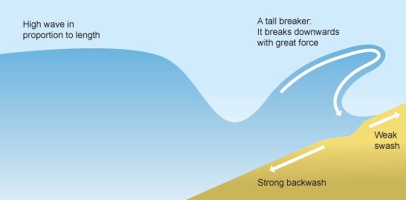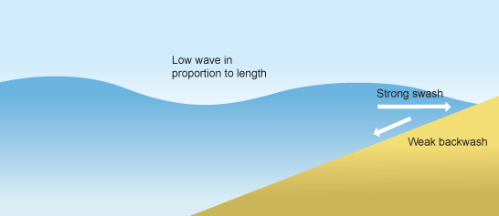There are two types of waves: constructive and destructive. Complete the table below to show the characteristics of each wave using the image to help you:

**Constructive**

**Destructive**

**Landforms resulting from erosion**

**Destructive**

**Erosional landforms**

The process of erosion can create different landforms along the coastline.

**Caves, arches, stacks and stumps**

Caves, arches, stacks and stumps are erosional features that are commonly found on a **headland**.

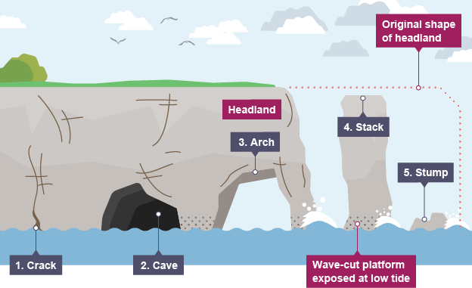

1. **Cracks** are widened in the headland through the erosional processes of hydraulic action (sheer power of water as it smashes against the cracks in the cliff) and abrasion (when pebbles grid along the cliff).
2. As the waves continue to grind away at the crack, it begins to open up to form a **cave**.
3. The cave becomes larger and eventually breaks through the headland to form an **arch**.
4. The base of the arch continually becomes wider through further erosion, until its roof becomes too heavy and collapses into the sea. This leaves a **stack** (an isolated column of rock).
5. The stack is undercut at the base until it collapses to form a **stump**.

**Different management strategies can be used to protect coastlines from the effects of physical processes**

**Hard engineering**

Erosion is a natural process which shapes cliffs. Over time, erosion can cause cliff collapse - therefore the coastline needs to be managed. Hard engineering involves building artificial structures which try to control natural processes. Each engineering strategy has its advantages and disadvantages.

**Sea walls:** Concrete walls that are placed at the foot of a cliff to prevent erosion. They are curved to reflect the energy back into the sea.

|  |  |
| --- | --- |
| **Advantages** | **Disadvantages** |
| * Effective at protecting the base of the cliff. * They absorb and deflect wave energy back to sea. * They act as a physical barrier and prevent flooding of the land behind them. | * Waves are still powerful and can break down and erode the sea wall. * Expensive - approximately £2,000 per metre. |

**Rock armour:** Large boulders placed at the foot of a cliff. They break the waves and absorb their energy.

|  |  |
| --- | --- |
| **Advantages** | **Disadvantages** |
| * If resistant rocks like granite are used they are eroded very slowly. * The rocks are dumped on top of each other leaving gaps between them that allow water through. * This disperses the energy of the waves and reduces their erosional power. | * They look different to the local geology, as the rock has been imported from other areas. * The rocks are expensive to transport. |

**Groynes:** Wooden or rock structures built out at right angles into the sea.

|  |  |
| --- | --- |
| **Advantages** | **Disadvantages** |
| * They trap sediment being carried by longshore drift. * They work by building up the amount of sand on the updrift side, acting as a buffer against wave attack, helping to protect the cliffs. | * By trapping sediment, it starves beaches further down the coastline, increasing rates of erosion elsewhere. * They look unattractive. |

**Section 4: River Landscapes in the UK**

**The shape of river valleys changes as rivers flow downstream**

# River profiles – long profile

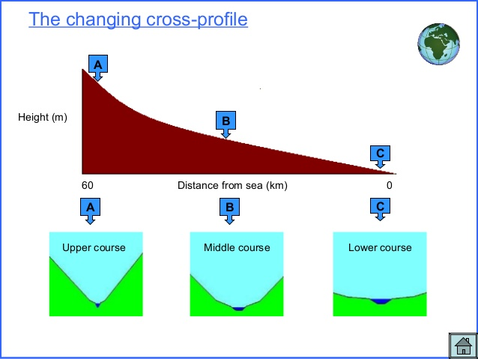

## **Cross profile**

A cross profile shows a cross-section of a river’s channel and valley at a certain point along the river’s course.

**A** - as the river flows downhill there is an increase in vertical erosion. The channel is shallow and narrow because there is not a lot of water in the channel.

* **B** – as the river flows into the middle course, there is some vertical erosion but more lateral erosion. The channel is wider and deeper as a result.
* **C** - in the lower course there is a lot less erosion, with only some lateral erosion. The channel is at its widest and deepest.

## **Waterfall and gorges**

A waterfall is a sudden drop along the river course. It forms when there are horizontal bands of resistant rock (hard rock) positioned over exposed, less resistant rock (soft rock).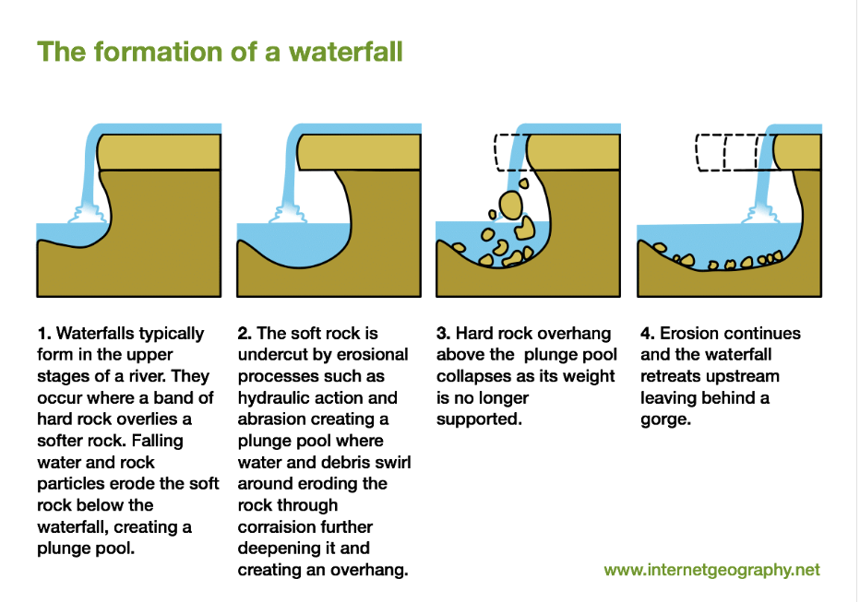

Draw annotated diagrams below to explain the formation of **waterfalls and gorges**:

|  |  |
| --- | --- |
| 1. A river flows over a band of hard rock on top of soft rock. | 2. |
| 3. | 4. |

**Different management strategies can be used to protect river landscapes from the effects of flooding**

**What is soft engineering?**

Soft engineering management is a more natural approach to manage flooding, such as floodplain zoning.

## **Flood warnings and preparation**

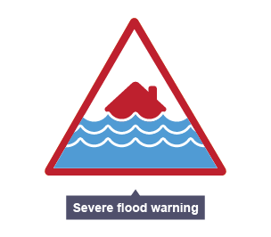The environmental agency monitors rivers and issues warnings via newspapers, TV, radio and the internet when they are likely to flood so people can prepare.

### Advantages

* People have time to protect their properties, eg with sandbags.
* Many possessions can be saved, resulting in fewer insurance claims.

### Disadvantages

* Some people may not be able to access the warnings.
* Flash floods may happen too quickly for a warning to be effective.
* They do not stop land from flooding - they just warn people that a flood is likely.

## **Floodplain zoning**

Allowing only certain land uses on the floodplain reduces the risk of flooding to houses and important buildings.

Advantages

* More expensive buildings and land uses are further away from the river, so have a reduced flood risk.
* Less damage is caused, leading to fewer insurance claims.

### Disadvantages

* Not always possible to change existing land uses.
* Planners have to decide what type of flood to plan for.

Complete the table below showing the advantages and disadvantages of hard and soft engineering:

|  |  |  |  |
| --- | --- | --- | --- |
| **Method** | **How it works / definition** | **Advantages** | **Disadvantages** |
| **Soft: Flood warnings and preparation** |  |  |  |
| **Soft: Floodplain zoning** |  |  |  |