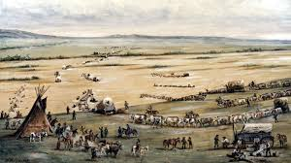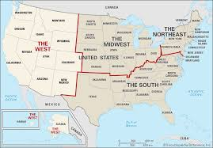

The American West Mock Exam Revision Notes

**Agreements with the Indigenous Peoples of the Plains**

Throughout the period 1840 -1890, the US government made a number of agreements with the indigenous peoples of the Plains In order to gain more land for the growing white American population.

These agreements promised the indigenous peoples, safety, security and an area of land that would be theirs forever. Every single one of these agreements was broken by the US government during this period of time.

For your exam, you will need to know the agreements below.

|  |  |
| --- | --- |
| Agreement. | Consequences |
| The Fort Laramie Treaty of 1851. | This aimed to allow settlers to travel across the Great Plains Using the Oregon Trail without being attacked by the indigenous peoples.  It also allowed the US government to build some roads and forts in their territory.  In return, the Indigenous peoples were promised:  $50,000 a year, every year for 50 years. |
| The Fort Laramie Treaty of 1868. | Fort Laramie Treaty Case Study | Teacher ResourceThis was signed to end Red Cloud’s War which the US government was losing. Red Cloud went to war when gold was discovered in the Rocky Mountains, and miners set up a new trail called the Bozeman Trail crossing Sioux land.    This Treaty created the Great Sioux Reservation. Only the indigenous peoples of the Plains were allowed to settle on that land.    As part of the treaty the US government also agreed to close all of its forts along the Bozeman Trail, which had been one of the main reasons for conflict. Red Cloud then burnt these to the ground. |

**Key Terms**

**Bozeman Trail-** A route used by settlers traveling to the gold fields in Montana during the 1860s. [It passed through the hunting grounds of the Sioux, leading to conflict](https://www.savemyexams.com/gcse/history/edexcel/18/revision-notes/the-american-west-c-1835-c-1895/development-of-the-plains-c1862-c1876/conflict-on-the-plains-1862-1868/).

**Homesteaders -** Settlers who moved west to claim land under the Homestead Act of 1862. [They were given 160 acres of land to farm at a very cheap cost. This helped to populate the Great Plains](https://www.savemyexams.com/gcse/history/edexcel/18/revision-notes/the-american-west-c-1835-c-1895/development-of-the-plains-c1862-c1876/conflict-on-the-plains-1862-1868/) with white Americans and achieve manifest destiny.

**Indigenous People-** [The Native American tribes who lived on the land long before European settlers arrived](https://www.savemyexams.com/gcse/history/edexcel/18/revision-notes/the-american-west-c-1835-c-1895/development-of-the-plains-c1862-c1876/conflict-on-the-plains-1862-1868/).

**Manifest Destiny -** Manifest Destiny was the 19th-century belief that God wanted the USA to be populated by loyal white Americans rather than the Indigenous peoples.

**Oregon Trail-** A 3,200 km route used by thousands of settlers moving west from Missouri to Oregon in the West in the mid-1800s.

**Transcontinental-** Something that spans or crosses an entire continent. [The transcontinental railroad, completed in 1869, connected the eastern and western United States, making travel across the USA much easier](https://www.savemyexams.com/gcse/history/edexcel/18/revision-notes/the-american-west-c-1835-c-1895/development-of-the-plains-c1862-c1876/conflict-on-the-plains-1862-1868/)

**Treaty-** A written agreement

**Reasons why White Americans crossed or settled the land of the Indigenous peoples (Plains Indians)**

1. **Gold Prospecting (searching for and discovering gold)**

|  |  |
| --- | --- |
| **Positive Impacts of the Gold Rush** | **Negative Impacts of the Gold Rush** |
| The aim of the US government was to achieve Manifest Destiny. This meant populating all of the United States with white Americans, not the indigenous peoples of the plains. Between 1848 and 1852 225,000 people moved to California as a result of the Gold Rush. This helped to achieve Manifest Destiny.    The gold that was mined was taxed by the US government. The money raised was used to help open up the West to white settlement. The discovery of gold also created demand for the railroad to be built and some of the profits from gold mining were used to pay for this to happen. The building of the railroad helped achieve Manifest Destiny. | Gold mining caused huge damage to the land. Chemicals  such as mercury, which was toxic, were used to find gold  Hydraulic mining used high-powered water to wash away  entire hillsides and large areas of forest were destroyed in order  to provide supports for the mines themselves.    This created conflict with the indigenous peoples of the  Plains because:   1. They saw the land as sacred and not something that could be bought or sold as land belonged to everyone. It was seen as being their mother as it provided them with everything they needed to survive. 2. They believed that land should be respected. It could not be bought or sold and should not be harmed by being farmed or mined for gold and other resources the white American felt were important.     The discovery of gold caused large numbers of white Americans to travel across the plains and settle on Indian land. This broke the Fort Laramie Treaty of 1851 which stated that white Americans would not be allowed to settle on land that had been given to the indigenous peoples of the P6lains. This caused conflict between white Americans and the indigenous peoples.    The large numbers of settlers disrupted the hunting grounds of the Indigenous peoples. They frightened off the buffalo which the Indians were dependent upon. Large numbers of buffalo were also hunted to provide food for the gold miners and other settlers. The Indigenous peoples needed the buffalo to survive so they fought to protect them. |

**Reasons why White Americans crossed or settled the land of the Indigenous peoples**

1. **The Importance of the Railroad**

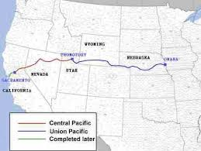

1. In1862 the US government passed the Pacific Railroad Act which paid for the building of the First Transcontinental Railroad which linked the east and west coasts of the USA. This made migration safer, easier and cheaper. People could now move West without risking getting lost, being attacked by the indigenous peoples or having to travel for months.
2. Not only did the US government pay for the railroad to be built it also gave the Union Pacific and Central Pacific companies which built it government land. The companies then sold the land to settlers who built their homes there. As a result, 200 million acres of land in the West was settled.

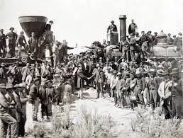

1. As the railroad was built so were railway stations. Around these stations new towns grew up and people settled there. They were able to buy and sell goods all over the USA as they could be taken on the trains to be sold. Cow towns such as Abilene were also set up. As the US government took more and more land away from the Indigenous peoples of the Plains it became easier for White Americans to settle on the Plains and achieve Manifest Destiny.

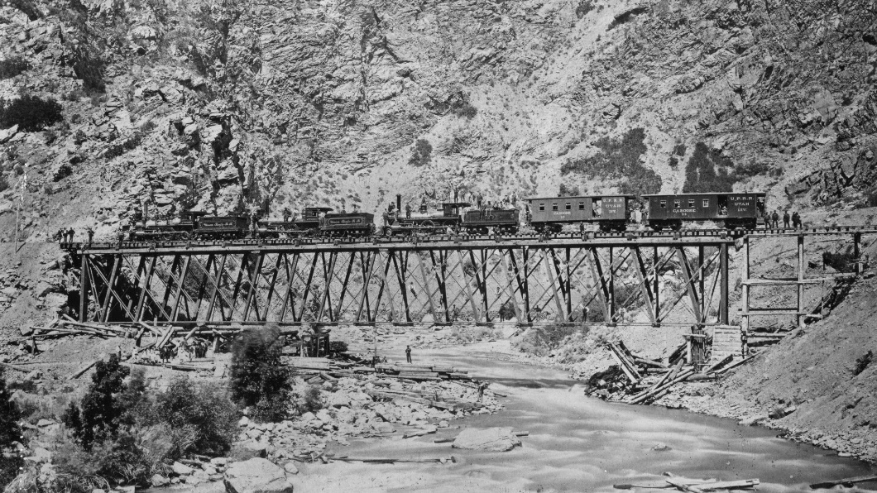

**Reasons why White Americans crossed or settled the land of the Indigenous peoples (Plains Indians)**

**3. To farm - The Homesteaders**

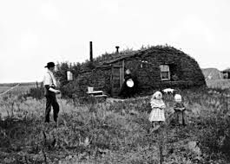Homesteaders were people who wanted to settle on the Great Plains and farm the land. They were influenced by the idea of ‘‘Manifest Destiny’’. Land on the Great Plains was also cheap and there was plenty of it. Some were ex-slaves, other ex-soldiers and some were just people from the East who couldn’t afford land there.

The main problems were that it had never been farmed before so the ground was hard, often dry and there were no trees to build a home, fence in land or to burn as fuel.

Some were successful but others were not. The most important reason why some were so successful was the improvements in technology

|  |  |
| --- | --- |
| **Problems they faced** | **Technology related solutions** |
| Water Shortages | * 1874- Daniel Halliday invented a windmill which could pump water from underground. These were mass produced allowing other homesteaders to buy them. This allowed them to settle on areas with limited rainfall. * Dry farming was invented. This involved ploughing the land after heavy rainfall to trap moisture in the soil. The new, stronger ploughs allowed this to happen |
| Land too tough to plough | * John Deere invented the “sod-buster”, a strong plough which could cut through tough grass roots without breaking or bending. This meant that the ground could be turned over to plant seed. * A seed drill was developed that could plant seeds in hard ground at the correct depth for them to grow. |
| Buffalo and cattle straying onto crops | * 1874- Joseph Glidden invented barbed wire to fence off land. This prevented buffalo and cattle from destroying crops, allowing homesteaders to survive. |
| Many crops not suited to the weather conditions | * Russian immigrants introduced Turkey Red wheat; a crop more suited to the climate on the plains. This meant that crops could be grown on drier land with limited nutrients. |

**Who Migrated across the USA?**

There were many different types of people. Some were:

1. Pioneers and Settlers: Many families and individuals moved westward in search of new opportunities, land, and a better life.
2. [Gold Prospectors:](https://www.savemyexams.com/gcse/history/edexcel/18/revision-notes/the-american-west-c-1835-c-1895/the-early-settlement-of-the-west-c1835-c1862/what-factors-encouraged-western-migration/) People searching for gold.
3. Homesteaders: People who set up farms on the Great Plains.
4. [Railroad Workers:](https://www.savemyexams.com/gcse/history/edexcel/18/revision-notes/the-american-west-c-1835-c-1895/the-early-settlement-of-the-west-c1835-c1862/what-factors-encouraged-western-migration/) People who built the transcontinental railroad.
5. The Mormons: People who followed the religion of Mormonism and had to move to the isolated Salt Lake Valley to avoid persecution by non-Mormons.

**The Mormon Migration 1846-7**

Mormonism was founded by Joseph Smith and by the 1840 he had several thousand followers

They Mormons were often unpopular with non-Mormons because:

1. They were against slavery.
2. They were often successful due to their belief in hard work.
3. They believed it was allowed to have more than one wife (polygamy). This went against Christian beliefs.
4. A bank set up by them collapsed in 1866 in the state of Ohio meaning many people lost money.

Eventually, their new leader, **Brigham Young**, decided that they needed to settle in an isolated area. This was the Great Salt Lake Valley in Utah.

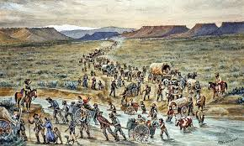**A description of the Mormon migration.**

1. Preparations had begun in 1845 with wagons being built and oxen bought.
2. The journey was very organised, because Brigham Young split everyone in to groups, gave everyone a specific role and taught them how to form their wagons into a circle for safety. Each group had a captain who was in charge
3. In 1847, Young led the first party along the same route as the Donner Party, but he had carefully researched the route in advance. Young’s party had enough food for a year, and the group was specially chosen for their skills to pick out the best route, improve the trail and mark out water sources and grass for the animals.
4. In the places they stopped they set up base camps for groups to rest, repair wagons and planted crops so they would have food. The largest camp was called Winter Quarters
5. This prepared the way for the next wagon train of 1500 Mormons.
6. After arriving at the Salt Lake Valley, Young returned to Winter Quarters to guide the next group.
7. Between 1847 and 1869 70,000 Mormons followed the ‘Mormon Trail’, arriving safely at the Salt Lake Valley.

**Types of Question**

1.Explain one consequence of… (4)

2. Explain one consequence of… (4)

**The first 2 questions are the same but ask you to explain a consequence of 2 different events.**

3. Write a narrative account analysing... (the question then mentions an event it wants you to look at) (8)

An example would be

**Write a narrative account analysing the ways in which the cattle industry grew 1865-1874**

* Start with the first event
* Link it to the next with the connective ‘As a result’
* Link this event to another event with the same connective ‘As a result’
* Do this again, if necessary, before ending your account

Structure strip 3 shows you how to write this answer

1. Explain the importance of… to…. (8)

You are given 3 topics and you choose 2.

Aim for 2 explained reasons for each topic. For example:

An example would be:

**‘Explain the importance of the buffalo to the Indigenous peoples’**

**The buffalo was important to the indigenous peoples because...**

**The buffalo was also important because…**

The more detail you add in the better.

**Guess your mock exam questions**

Use your revision booklet to try to guess and plan the answers to the questions on your paper

|  |  |
| --- | --- |
| Explain one consequence of |  |
| Explain one consequence of |  |
| Explain one consequence of |  |
| Explain one consequence of |  |
| Explain one consequence of |  |
| Explain one consequence of |  |
| Explain one consequence of |  |
| Explain one consequence of |  |

|  |  |
| --- | --- |
| Explain the importance of  to |  |
| Explain the importance of  to |  |
| Explain the importance of  to |  |
| Explain the importance of  to |  |

Write narrative account analysing________________________________________________  
______________________________________________________________________________________________________________________________________________________  
________________________________________________________________________________________________________________________________________________________________________________________________________________________________________________________________________________________________________________________________________________________________________________________________________________________________________________________________________________________________________________________________________________________________________________________________________________________________________________________________________________________________________________________________________________________________________________________________________________________________________________________________________________________________________________________________________________________________________________________________________________________________________________________________________________________________________________________________________________________________________________________________________________________________________________