GCSE Geography Revision Booklet

Paper 1: Living with the physical environment
Length of exam: 1 hour and 30 minutes
Section A: The challenge of natural hazards
- Tectonic hazards
- Weather hazards
- Climate change

Section B: The Living World
- Ecosystems
- Tropical Rainforests
- OPTION: COLD ENVIRONMENTS

Section C: Physical landscapes in the UK
- OPTION 1: COASTAL LANDSCAPES
- OPTION 2: RIVER LANDSCAPES
Answer questions: 1, 2, 3 and 4
Don’t answer question 5

Preparation for Y11 mock exams November 2025

Name: …………………………………………………………………………………………….
Section A: The challenge of natural hazards
A natural hazard is a natural event that poses a risk to human life and/or property. Take for example a volcanic eruption that occurs underneath the Atlantic Ocean. These events happen frequently but because they do not impact people they are not described as a natural hazard.
Haiti earthquake: 12th January 2010 (LIC)
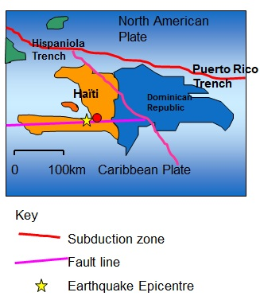
Haiti is an LIC and considered the poorest country in the western hemisphere, with a GDP of approximately $1500 per person per year in 2023.
Haiti shares the island Hispaniola with the Dominican Republic in the Caribbean.

Causes
- The Haiti earthquake was caused by the North America Plate sliding past the Caribbean Plate at a conservative plate margin.
- Both the North American Plate and Caribbean Plate move in the same direction, but one moves faster than the other. This causes friction and pressure to build up.
- The friction between the two tectonic plates eventually released causing a magnitude 7 earthquake on the Richter scale with an epicentre 16km south west of Port-au-Prince and a shallow focus of 5 miles.
- Haiti was struck by an earthquake at 16:53 (4:53pm) local time on Tuesday 12 January 2010. At the time there were 3 million people living in the capital city Port-au-Prince. Most people lived in slums.
- On August 14, 2021, another earthquake with a magnitude of 7.2 hit the western side of the country killing at least 2,200 people.

Effects of the Haiti earthquake
Primary effects | Secondary effects
- The earthquake struck in a densely populated area killing 250,000 people  - 1.3 million people were made homeless.  - 3 million people were affected by the earthquake.  - 250,000 homes and 30,000 other buildings were destroyed  - The estimated cost of damage was $14 billion.  - Transport and communication links were also badly damaged  - Hospitals (50+) and schools (1,300+) were badly damaged, as was the airport’s control tower  - The main prison was destroyed and 4,000 inmates escaped | - 1 in 5 people (20%) lost their jobs  - Haiti’s largest industry, clothing was one of the worst affected  - The large number of deaths meant that hospitals and morgues became full and bodies then had to be piled up on the streets  - The large number of bodies left lining the streets meant that diseases, especially cholera, became a serious problem.  - It was difficult getting aid into the area because of the damage to the airport  - People were squashed into shanty towns or onto the streets because their homes had been destroyed leading to poor sanitation and health, and looting became a real problem

Immediate Responses
- Due to the port being damaged, aid was slow to arrive.
- The USA sent rescue teams and 10,000 troops.
- Bottled water and purification tablets were provided.
- 235,000 people were moved away from Port-au-Prince to less-damaged cities.
- £20 million was donated by The UK government.

Long-term Responses
- As one of the poorest countries on Earth, Haiti relied on overseas aid.
  - Although the response was slow, new homes were built to a higher standard using the cash for work programme.
  - Over one million people still lived in temporary shelters one year after the earthquake.
- The port needed rebuilding, which required a large amount of investment.

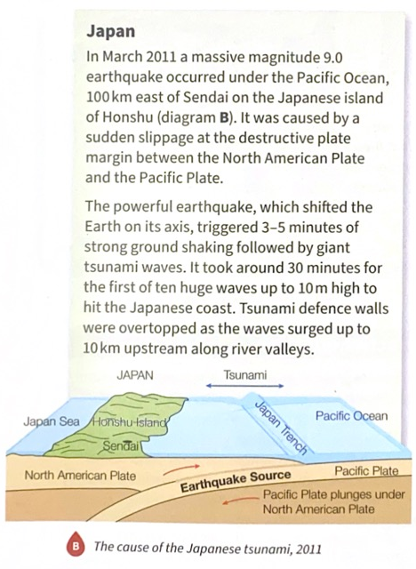
Japan earthquake and tsunami: 11th March 2011 (HIC)

Effects of the Japanese earthquake
Primary effects
Violent ground shaking for up to five minutes caused many injuries and some deaths as buildings collapsed. | Over 4 million people in north east Japan were left without electricity and 1.5 million without water.
In eastern Tohoku, roads and rail lines were damages, electricity knocked out, and water and sewerage systems disrupted. | Ground shaking destroyed thousands of homes in Fukushima, Ibaraki and Chiba prefectures.
Secondary effects
The 10m high tsunami waves caused almost all of the 18 000 deaths and 500 000 homeless attributed to the earthquake. | Explosions at the Fukushima nuclear power plant led to the evacuation of 100 000 people due to fear of radioactive leaks.
About 560km2 of coastal land (farmland, towns and cities) were inundated. | Total damages, estimated at US$235billion (World Bank data) made it the costliest global natural disaster on record.

Immediate and long-term responses
Immediate response | Long-term response
Search and rescue teams from Japan and abroad, with 100 000 members of the Japanese Self-Defence Force, worked for several days, yet there were few survivors | The Reconstruction Design Council devised a long-term plan (2012-2022) for the region, identifying zones for reconstruction with simpler planning procedures.
500 000 people were evacuated to higher ground before the tsunami struck. Many had their homes destroyed and needed emergency shelter, food and water. | By 2020 nearly 30 000 units of public housing had been completed, replacing almost all of the temporary homes. Industrial production had returned to pre-disaster levels and almost all farmland and seafood processing plants had been restored.
Within a few weeks some roads and railway networks had been restored, improving access to the region. | By early 2015 most debris had been cleared and new housing constructed away from low-lying coastal areas.
Japan had 60 seconds warning time before the quake struck. This meant that text messages could be sent to the people in Japan. | In 2013 an ungraded tsunami warning system was launched, providing faster and more accurate forecasts. Sea walls (up to 12.5m high) and embankments have been constructed to protect cities, industries and power plants.
Power was soon restored but supply was intermittent due to the explosions at the Fukushima nuclear power plant caused by the tsunami. | Tax incentives promoted investment in industry and business. A reconstruction budget of over US$150 billion was created.

TASK: Complete the table comparing the Haiti and Japan earthquakes
 | Haiti (LIC) | Japan (HIC)
Date
Cause (include magnitude, plate boundary and name of plates)
Primary effects (choose the 2 most significant)
Secondary effects (choose the 2 most significant)
Immediate responses (choose 2 for each)
 | Haiti (LIC) | Japan (HIC)
Long term responses (choose 2 for each)
Extreme weather
- Storm Babet occurred in the UK on 20th October 2023
- Two months of rainfall fell in two days
- The rain came on top of very wet weather earlier in October meaning the ground was already saturated
Impacts of Storm Babet
Social effects are things that affect people.
Economic effects are things that affect jobs and income
Environmental effects are things that affect land, air and water.
Social effects | Economic effects | Environmental effects
Schools across the region closed. Hundreds of people are homeless after flash floods followed heavy rain. An estimated 1,250 properties in England were flooded. | Storm Babet disrupted power supplies, with around 100,000 customers initially losing power. | The storm caused widespread flooding, which damaged rivers, lakes, and wetlands. The flooding also displaced wildlife and polluted water supplies.
Seven people died due to the effects of the storm, which included heavy rainfall, leading to flooding, and high winds causing trees to topple. | Many businesses were damaged by flooding and power outages. This led to job losses and disruption to economic activity. Forty-five workers were airlifted off a North Sea drilling platform after it lost anchors during the storm. | The heavy rains caused landslides in some areas. This damaged forests and other natural habitats.
Over 10,000 people were evacuated from their homes due to flooding. Many people were forced to stay in temporary accommodation, such as shelters and hotels. | The storm caused billions of pounds in lost revenue for businesses. This was due to damage to property, disruption to supply chains, and reduced demand for goods and services. | The storm caused pollution to water supplies and wildlife habitats. This was due to factors such as sewage overflows and agricultural runoff.
TASK: Storm Babet example
Information
General facts and causes
Information
Social effects (choose 2)
Economic effects (choose 2)
Environmental effects (choose 2)

Reducing effects of tropical storms
There are a number of strategies to reduce the impacts of tropical storms. These include:
Prediction | Using historical evidence so that scientists can estimate when/where a hazard is likely to occur.
Planning | Identifying and avoiding areas that are assessed to be the most at-risk due to a hazard.
Monitoring | Using equipment and technology to detect warning signs that an event will occur.
Protection | Designing buildings or adding structures to buildings or areas that will prevent the effects of a hazard

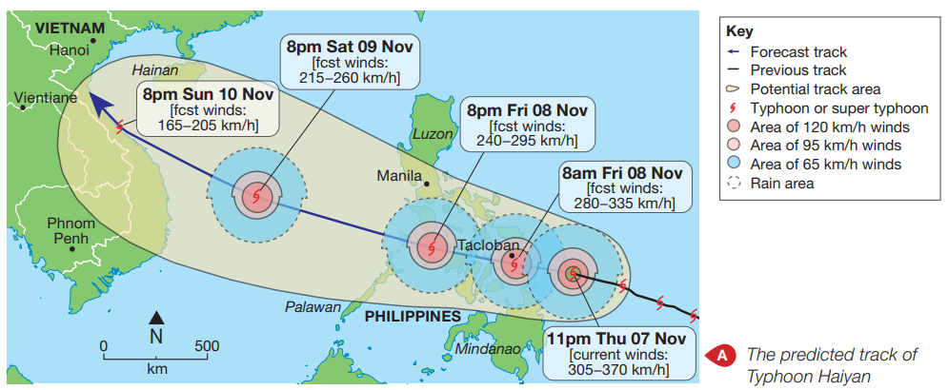
- Monitoring and prediction

Map A shows the location of Typhoon Haiyan at 11pm local time on Thursday 7th November 2013. This was just 9 hours before it struck the island of Leyte and flattened most of the city of Tacloban. The map shows the predicted track of the tropical storm across the Philippines.
- Monitoring and prediction is useful because it can be used to evacuate areas to get people to safety which reduces overall impacts. It can be used to know where to direct resources e.g. medical help / rescue teams
- The limitations of monitoring and prediction is that it doesn’t stop the hazard from occurring. People may not think it will impact them, but the storm could change direction / route
- Protection
There are a number of options available to protect people from the hazards associated with tropical storms.

Strategy | How this reduces the effects of tropical storms…
Windows, doors and roofs reinforced. | This ensures that houses remain intact so that repair costs are less, and so that people are less likely to be injured by flying debris such as broken glass.
Storm drains constructed in urban areas (towns and cities). | This removes water quickly from urban areas which reduces the risk of houses, businesses and other important buildings flooding and causing damage.
Sea walls built along the coast. | This protects areas near the coast from flooding due to the storm surge that is created by tropical storms.
Houses close to the coast constructed on stilts. | This means that if an area floods due to heavy rain or a storm surge then water will pass underneath instead of damaging the houses.

In some countries cyclone shelters are constructed that can provide shelter for many local residents, this is particularly common in LICs where local residents do not have the wealth to add protective measures to their own properties.

Features of a cyclone shelter

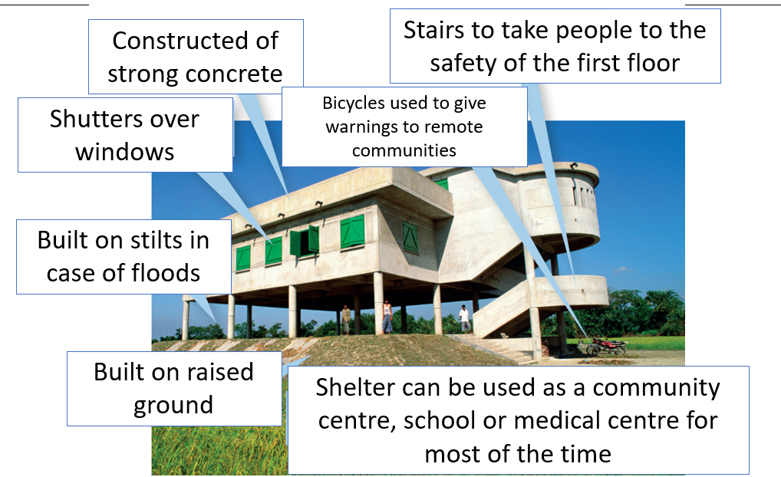

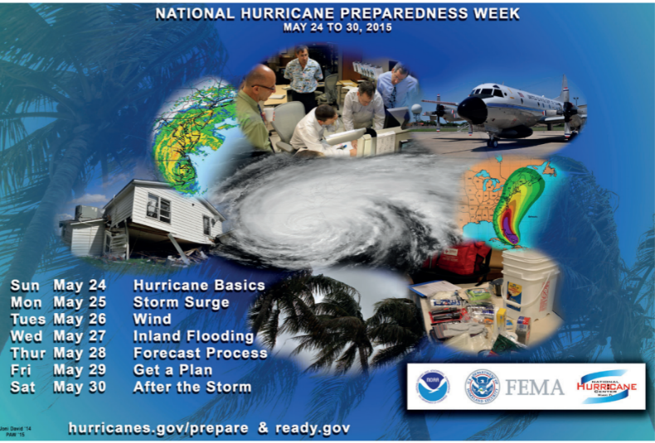
- Planning
It is not realistic to stop people living and working in coastal areas that are at risk from tropical storms. Many people rely upon fishing or tourism to make a living. Even in rich countries like the USA, urban developments have been allowed to take place on vulnerable barrier off the coast of Florida.
Planning to reduce the tropical storm hazard is mostly about raising individual and community awareness. For example, in the USA there is a National Hurricane Preparedness Week.

TASK: Complete the table which explains the different ways to reduce the impacts of a tropical storm
Strategy | Explain how this strategy reduces the impacts of tropical storms. Aim to include at least 2 ideas for each strategy
Monitoring and prediction
Protection
Planning

Climate change
The general opinion held today is that global temperatures are increasing and this is due to humans and our increasing use of fossil fuels, which has emitted high amounts of carbon dioxide into the atmosphere. This is causing our climate to change.
To reduce the amount of carbon emissions in our atmosphere and respond to the impacts of climate change there are 2 different strategies
Adaptation – responding to the effects of climate change to ensure that life can continue in as normal way as possible.

Mitigation – reducing the causes of climate change by reducing the concentration of greenhouse gases in the atmosphere.
Strategy | How this reduces greenhouse gases | Limitations/problems
Alternative energy production: the burning of fossil fuels (oil, coal and gas) to produce electricity, power vehicles and power factories contributes to 87% of human-produced CO2 emissions.  Alternative energy sources (e.g. hydro-electric, nuclear, solar and wind) are now being used more commonly. | Using alternative energy sources reduces the quantity of fossil fuels that are burned to generate electricity, which will reduce the amount of CO2 being released into the atmosphere. | It is very expensive to build alternative power stations (e.g. nuclear)  The infrastructure needed for widespread electric vehicle use is lacking in many countries
Carbon capture and storage (CCS): Technology is being developed where CO2 that is produced by burning fossil fuels to generate electricity or in factories, is captured.  It is then converted into a liquid and injected into a suitable space underground. | There will be less CO2 emitted into the atmosphere as it is stored underground. | Not all of the CO2 emitted will be captured using this method  It is difficult to find locations where the liquid can be injected underground, so cannot be done everywhere

TASK: Explain how alternative energy use can help reduce the impacts of climate change
Alternative energies are ______________________________________________________________
__________________________________________________________________________________
__________________________________________________________________________________
__________________________________________________________________________________
__________________________________________________________________________________
TASK: Explain how carbon capture use can help reduce the impacts of climate change
Carbon capture is ___________________________________________________________________
__________________________________________________________________________________
__________________________________________________________________________________
__________________________________________________________________________________
__________________________________________________________________________________
__________________________________________________________________________________
Section B: The living world
Characteristics of tropical rainforests
- Tropical rainforests are mostly found in a band around the Earth between the Tropic of Cancer (23°N) and the Tropic of Capricorn (23°S). They are most abundant though at lower latitudes close the equator between 10°N and 10°S.
- The sun’s rays are more concentrated at the equator so it warms up quickly.
- This produces convectional rainfall – heavy intense rainfall.
- The large inputs (sun and rain) lead to the quick growing conditions and therefore a large diversity of vegetation.

Climate of tropical rainforests
- The temperature is generally between 26-28°C and only varies a few degrees over the year.
- Rainfall is very high, around 2000mm per year and it rains every day.
- The climate is the same all year round. There are no definite seasons.

Plant adaptations in tropical rainforests
Image | 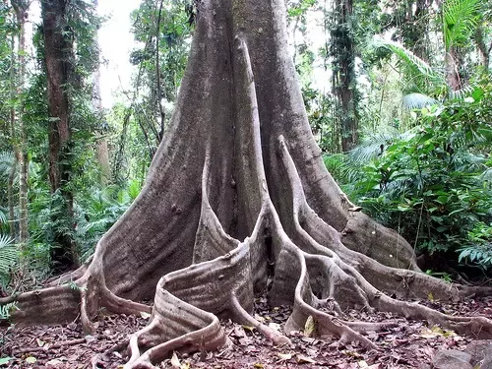 | 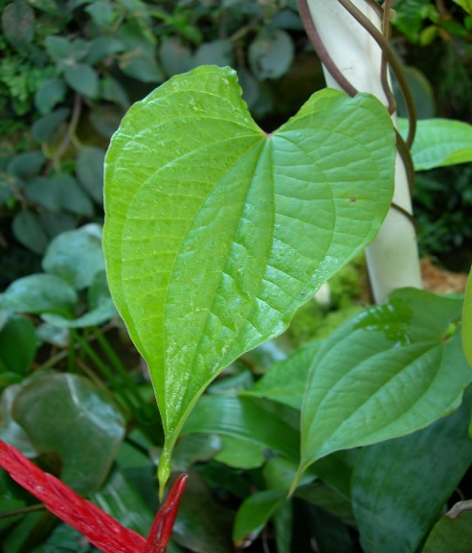
Adaptation | Buttress roots are wide roots found at the base of kapok trees (emergent layer). This wide base helps the tree to thrive in the tropical rainforest. | Drip-tip leaves  These leaves have a waxy surface, and a drip-tip that allows water to run-off them easily.
Supporting reasons | 1. They create a STABLE BASE in order to help the tree to grow tall. This is important because it helps the tree to penetrate the CANOPY layer, helping it to gain SUNLIGHT in order for PHOTOSYNTHESIS to occur, so that the plant can produce energy.  2. Most of the NUTRIENTS in the rainforest are found in the LITTER where DECOMPOSERS have broken down dead matter, therefore the roots being shallow enables them to uptake the optimal amount of nutrients. If the roots were deep in the SOIL this would not benefit the tree, as the soil is lacking nutrients. | 1. If water were to remain on the leaf then it could be DAMAGED, this would be a problem because leaves are where plants absorb sunlight for PHOTOSYNTHESIS. If many of a plant’s leaves were damaged this would decrease the amount of energy that the plant could provide for itself.  2. If water were to remain on the leaf then it could encourage the GROWTH of BACTERIA and FUNGI on the leaf. If this occurs, it reduces the surface area that the plant has to absorb sunlight for PHOTOSYNTHESIS therefore reducing energy the plant can produce.

Value of tropical rainforests
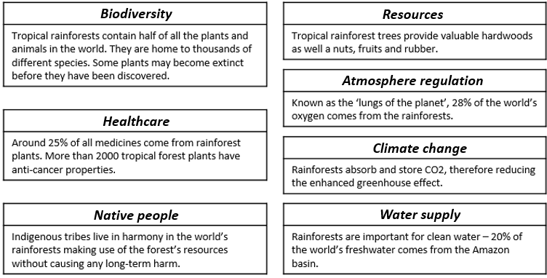
TASK: Select two reasons why tropical rainforests are important for PEOPLE. Explain your reasons below
__________________________________________________________________________________
__________________________________________________________________________________
__________________________________________________________________________________
__________________________________________________________________________________
__________________________________________________________________________________
TASK: Select two reasons why tropical rainforests are important for ENVIRONMENT. Explain your reasons below
__________________________________________________________________________________
__________________________________________________________________________________
__________________________________________________________________________________
__________________________________________________________________________________
__________________________________________________________________________________

Challenges of development in Svalbard (a case study of a cold environment)
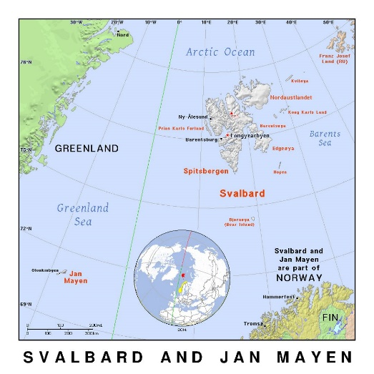
Where is Svalbard?
- Svalbard is the most northerly permanently inhabited territory. It is located close to the Mid-Atlantic Ridge and has 5 major islands
- Svalbard is a territory of Norway.
- 60% of the land is covered in glaciers and the rest of the land is tundra. There are no trees as it is too cold.
- Most of the population of around 2700 live in the main town of Longyearbyen

Development  challenge | Key information | Why is it a challenge? | How is the challenge overcome? (managed)
Extreme temperatures | Temperatures reach as low as -30⁰C in Longyearbyen, and colder in the more northern glacial regions. | It is dangerous to work outside with a serious risk of frostbite. People have to dress very warmly and this can make outdoor work very slow and difficult therefore reducing productivity. | People have to wear 4 layers to keep warm e.g. layer 1 - thermal underwear, layer 2 - turtle neck or fleece sweater and trousers, layer 3 - thick sweater, scarf, padded trousers, layer 4 – boots, gloves, winter jacket, hat.
Construction | A range of different types of construction needs to be carried out including: building houses, shops and offices, maintaining roads, constructing and enlarging harbour facilities, constructing mining operations to extract coal. | Working outdoors in extreme temperatures and also in limited light during the winter is very demanding.  The frozen ground (permafrost) can provide good solid foundations but it has to be protected from melting, if it does it becomes unstable and could lead to buildings and roads cracking or even collapsing. | Most construction work is carried out during the brief summer period.  Most roads are dirt or gravel roads raised up above the ground surface. These roads are relatively cheap and easy to maintain from year to year.
Services | Water, electricity and sanitation services are needed for the resident population and tourists. | Pipes need to be kept off the ground to prevent them causing any possible thawing of the permafrost. | Overground heated water and sewage pipes allows for easy maintenance and so that the permafrost does not melt.
Accessibility | Svalbard is located in a remote part of Europe and can only be reached by plane or ship. | The islands are inaccessible and almost all transport systems are restricted to the immediate area around Longyearbyen.  No roads serve outlying communities. | There is one airport close to Longyearbyen capable of handling international flights from Norway and Russia. Smaller aircraft can be used to connect to other islands.  There is 50km of road in Longyearbyen.  Most people use snowmobiles, particularly in the winter.
TASK: Choose 2 challenges of development in Svalbard. Explain each challenge and how the challenge is overcome.
Challenge 1: The challenge of development in Svalbard is ___________________________________
This is challenge because _____________________________________________________________
__________________________________________________________________________________

__________________________________________________________________________________

__________________________________________________________________________________

__________________________________________________________________________________

__________________________________________________________________________________

__________________________________________________________________________________

Challenge 2: The challenge of development in Svalbard is ___________________________________
This is challenge because _____________________________________________________________
__________________________________________________________________________________

__________________________________________________________________________________

__________________________________________________________________________________

__________________________________________________________________________________

__________________________________________________________________________________

__________________________________________________________________________________

Section C: UK Landscapes

Coastal Landscapes in the UK

The process of erosion (hydraulic action, abrasion, attrition, solution) can create different landforms along the coastline.

Caves, arches, stacks and stumps
Caves, arches, stacks and stumps are erosional features that are commonly found on a headland.
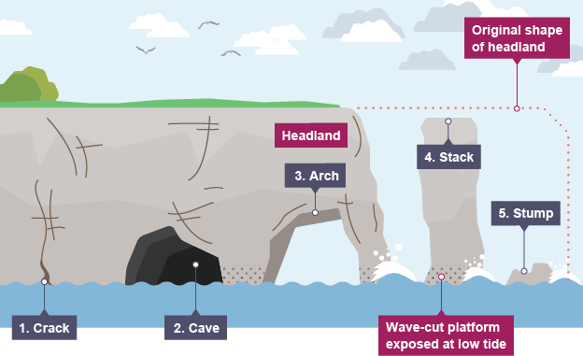
- Cracks are widened in the headland through the erosional processes of hydraulic action (sheer power of water as it smashes against the cracks in the cliff) and abrasion (when pebbles grid along the cliff).
- As the waves continue to grind away at the crack, it begins to open up to form a cave.
- The cave becomes larger and eventually breaks through the headland to form an arch.
- The base of the arch continually becomes wider through further erosion, until its roof becomes too heavy and collapses into the sea. This leaves a stack (an isolated column of rock).
- The stack is undercut at the base until it collapses to form a stump.

TASK: Explain the formation of CCASS (use the information above)

__________________________________________________________________________________

__________________________________________________________________________________

__________________________________________________________________________________

__________________________________________________________________________________

__________________________________________________________________________________

__________________________________________________________________________________

__________________________________________________________________________________
What are the different hard engineering strategies used to manage coastal areas?

Hard engineering
Erosion is a natural process which shapes cliffs. Over time, erosion can cause cliff collapse - therefore the coastline needs to be managed. Hard engineering involves building artificial structures which try to control natural processes. Each engineering strategy has its advantages and disadvantages.

Sea walls: Concrete walls that are placed at the foot of a cliff to prevent erosion. They are curved to reflect the energy back into the sea.
Advantages | Disadvantages
- Effective at protecting the base of the cliff.  - They absorb and deflect wave energy back to sea.  - They act as a physical barrier and prevent flooding of the land behind them. | - The sea walls can be undercut which is a severe problem if not dealt with effectively.  - They are very expensive to build and keep in good condition (for example, dependent on the complexity of the build, it is between £5 000 to £10 000 per metre).

Rock armour: Large boulders placed at the foot of a cliff. They break the waves and absorb their energy.
Advantages | Disadvantages
- The rocks force the waves to break and so absorb the power of the waves.  - They form a protective barrier and offer good protection to the cliffs or to valuable land behind them.  - If resistant rocks like granite are used they are eroded very slowly. | - They look different to the local geology, as the rock has been imported from other areas.  - The rocks are expensive to transport.

Groynes: Wooden or rock structures built out at right angles into the sea.
Advantages | Disadvantages
- They trap sediment being carried by longshore drift.  - They work by building up the amount of sand on the updrift side, acting as a buffer against wave attack, helping to protect the cliffs. | - By trapping sediment, it starves beaches further down the coastline, increasing rates of erosion elsewhere.  - They look unattractive.

TASK: Explain how at least two hard engineering strategies protect coastal areas including their advantages and disadvantages.

One way to protect coastal areas is _____________________________________________________
__________________________________________________________________________________

__________________________________________________________________________________

__________________________________________________________________________________

__________________________________________________________________________________

Another way to protect coastal areas is __________________________________________________
__________________________________________________________________________________

__________________________________________________________________________________

__________________________________________________________________________________

__________________________________________________________________________________

__________________________________________________________________________________

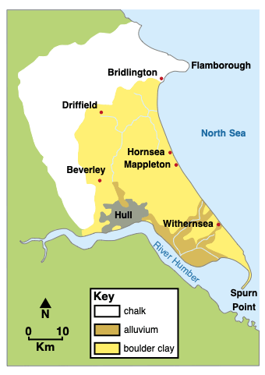
Coastal management on the Holderness Coast
Located on the east coast – from Flamborough Head (chalk headland) to Spurn Point. Most of the coast is boulder clay – erodes quickly
It is the fastest eroding coastline in Europe
There are many coastal towns that are important to the economy e.g. Bridlington
There are sea walls and groynes at Bridlington and Hornsea
There is a rock groyne located Mappleton
Coastal erosion has been reduced at the coastal towns, but areas further down the coast have continued to suffer from greater rates of erosion e.g. Great Cowden.

Colour code the information above in the following ways:
  - The coastal management strategies used on the Holderness Coast (one colour)
  - The impact of these coastal management strategies (another colour)

River Landscapes in the UK
A waterfall is a sudden drop along the river course. It forms when there are horizontal bands of resistant rock (hard rock) positioned over exposed, less resistant rock (soft rock).
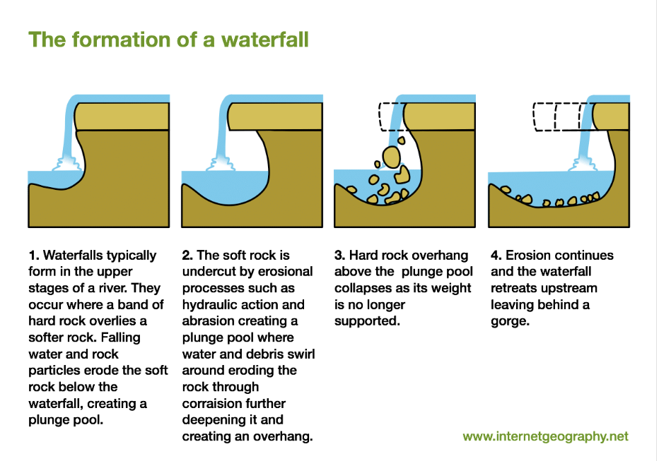
1. A river flows over a band of hard rock on top of soft rock. | 2.
3. | 4.
TASK: Draw annotated diagrams above to explain the formation of waterfalls and gorges:
Different management strategies can be used to protect river landscapes from the effects of flooding

What is soft engineering?
Soft engineering management is a more natural approach to manage flooding, such as floodplain zoning.

Flood warnings and preparation
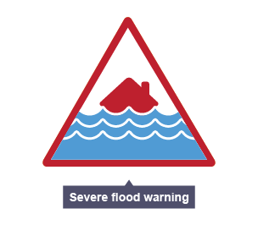
The environmental agency monitors rivers and issues warnings via newspapers, TV, radio and the internet when they are likely to flood so people can prepare.

Advantages
- People have time to protect their properties, eg with sandbags.
- Many possessions can be saved, resulting in fewer insurance claims.

Disadvantages
- Some people may not be able to access the warnings.
- Flash floods may happen too quickly for a warning to be effective.
- They do not stop land from flooding - they just warn people that a flood is likely.

Floodplain zoning
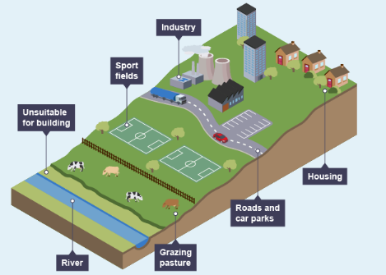
Allowing only certain land uses on the floodplain reduces the risk of flooding to houses and important buildings.
Advantages
- More expensive buildings and land uses are further away from the river, so have a reduced flood risk.
- Less damage is caused, leading to fewer insurance claims.

Disadvantages
- Not always possible to change existing land uses.
- Planners have to decide what type of flood to plan for.

TASK: Explain how at the two soft engineering strategies above reduce the risk of river flooding. Include their advantages and disadvantages.

One way to reduce river flooding is _____________________________________________________
__________________________________________________________________________________

__________________________________________________________________________________

__________________________________________________________________________________

__________________________________________________________________________________

__________________________________________________________________________________

__________________________________________________________________________________

__________________________________________________________________________________
Another way to reduce river flooding is __________________________________________________
__________________________________________________________________________________

__________________________________________________________________________________

__________________________________________________________________________________

__________________________________________________________________________________

__________________________________________________________________________________

__________________________________________________________________________________

__________________________________________________________________________________

Flood management in Sheffield
There are 4 big rivers (Don, Loxley, Sheaf and Porter) that run through Sheffield. On 25th June 2007 there was a flood in Sheffield. As a result of this a number of flood management strategies have been implemented.
Strategy 1:
Cutting down trees in the River Don. Cleared blocked drains and removed debris from the River Don. This helps to reduce the chance of the river of flooding because clearing blocked drains means water can run into the river and increase surface run-off. By removing debris, it ensures that there is a greater capacity of water in the river so in times of flood it can hold more water.
Strategy 2:
Building concrete raised river walls next to the River Don.
This helps to reduce the chance of the river of flooding because it increases the capacity of water in the river so in times of flood it can hold more water, reducing the risk of the land flooding. In 2019 only 40 properties were flooded. However, homes in Doncaster were flooded as water was transferred further down the river.

Colour code the information above in the following ways:
  - The names of the rivers in Sheffield (one colour)
  - The river management strategies used in Sheffield (a second colour)
  - The way that the strategy reduces the risk of flooding (a third colour)

