Elizabethan England
Fantastic Five
Mock Exam

Revision

This Booklet is for students whose target grade is Grade 3-5-
You will be given 1 week to learn the knowledge on each topic
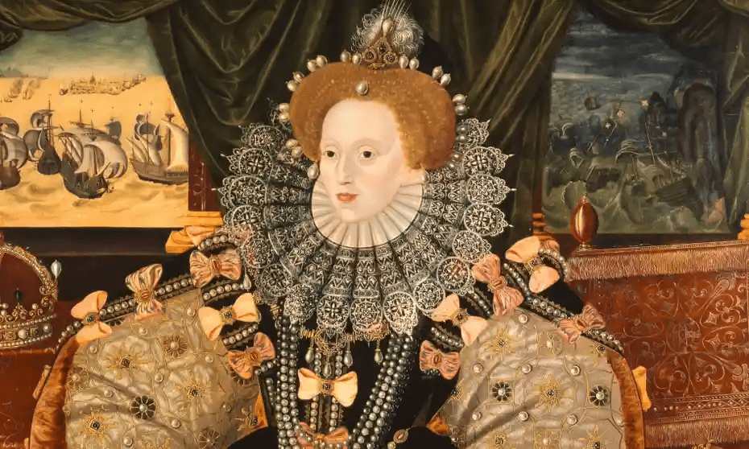
You need to complete the tasks in the booklet for that knowledge
You will be tested after that week to check you have done this.
The test will be exactly the same as the tasks in the booklet
Results below expectations will mean that the test will be redone.

Elizabeth’s Religious Settlement
The previous monarch (Queen Mary I) had been Catholic so she had made the country follow the Catholic religion (Catholicism). The monarch before that had been Protestant. The country was very divided. It would be almost impossible to find a solution everyone was happy with but Elizabeth tried. Her solution is known as her religious settlement
Fantastic 5 | Pictures
- The Act of Supremacy 1559

- This made Elizabeth the Supreme Governor of the Church, taking power away from the Catholic Pope.

- The Royal Injunctions 1559
These were rules for worship that Queen Elizabeth I introduced. These said that all clergy had to:
- teach the Royal Supremacy (that Elizabeth was the Supreme Governor (Head) of the Church)

  - The Act of Uniformity (1559)
- This made Protestantism England’s official religion.
- Churches were much plainer (priests wore plainer robes) but churches still had stained glass windows.

5. Elizabeth said that everyone had to attend the Protestant Church.
- Those that didn’t were called recusants and had to pay a fine. This was a much less harsh punishment than she could have introduced. Many Catholics chose to pay the fine.

Elizabeth I's Religious Settlement - Activities

🧠 Comprehension Questions
1. What title did Elizabeth take in the Church of England?

2. Who lost power because of the Act of Supremacy?

3. Why did Elizabeth choose the title 'Supreme Governor' instead of 'Head'?

4. How did this Act affect the Pope’s authority in England?

5. What year was the Act of Supremacy passed?

✅ True or False
1. The Act of Supremacy made Elizabeth the Supreme Governor of the Church.
2. The Pope gained more power in England after 1559.
3. Elizabeth wanted to completely remove all Catholic traditions.
4. The Act of Supremacy was passed in 1559.
5. Elizabeth’s title showed she was in charge of religion in England.

✏️ Gap Fill
Fill in the blanks using the words: Elizabeth, Pope, Church, Supreme, 1559
1. The Act of Supremacy was passed in _________.
2. It made ____________ the Supreme Governor of the __________________ of England.
3. This took power away from the _______________-____.
4. Elizabeth chose the title ____________________ Governor to avoid upsetting Catholics.
5. The Act gave ___________________ control over religious matters in England.

🔍 Find It, Fix It Paragraph

Read the paragraph and correct the 5 mistakes using the information you have read

In 1558, Queen Mary made a law called the Act of Supremacy. It said the Pope was in charge of the Church. This gave more power to Catholics. Elizabeth wanted to be called Head of the Church to annoy Catholics.

How successful was Elizabeth’s Religious Settlement?
Fantastic 5 | Picture
- A Middle Way
- While England did become Protestant, some elements of Catholicism remained such as stained-glass windows. This meant that Catholic opposition was initially less than might have been expected.

Stability:
- Once the religious settlement was in place, it stayed mostly the same for the rest of Elizabeth’s reign. This gave people a sense of stability

No Widespread Revolts:
- Although there were some Catholic rebellions, like the Revolt of the Northern Earls in 1569, most people accepted the settlement.

BUT there was some serious opposition

Catholic Plots and Mary, Queen of Scots:
- Some Catholics didn’t accept Elizabeth as queen and wanted to replace her with Mary, Queen of Scots, who was Catholic. There were several plots, like the Ridolfi Plot and the Babington Plot supported by Spain

Puritan Opposition and the Crucifix Crisis:
- Puritans were strict Protestants who wanted to remove all Catholic elements from the Church. They didn’t like things like crucifixes (crosses) in churches. In the 'Crucifix Crisis', some bishops refused to put crucifixes in their churches. Elizabeth had to compromise and removed them but left her own up in her private chapel.

Elizabeth I's Religious Settlement

Elizabethan Religious Settlement Activities

🧠 Comprehension Questions (5)
1. What was the 'Middle Way' and how did it affect Catholic opposition?
2. How did the Religious Settlement bring stability to England?
3. What was the Crucifix Crisis and how did Elizabeth respond?
4. Why did some Catholics support Mary, Queen of Scots instead of Elizabeth?
5. What were the Ridolfi and Babington plots?

✅ True or False (5)
1. The Religious Settlement removed all Catholic traditions from churches.
2. Elizabeth removed crucifixes from churches after some bishops refused to use them.
3. The Babington Plot was supported by Spain.
4. The Religious Settlement changed many times during Elizabeth’s reign.
5. Puritans wanted to keep stained-glass windows and crucifixes in churches.

✏️ Gap Fill (5)
Fill in the blanks using the words: Elizabeth, Catholic, Puritans, stability, crucifixes
1. The Religious Settlement gave people a sense of ______.
2. Some ______ wanted to remove all Catholic elements from the Church.
3. Queen ______ had to compromise during the Crucifix Crisis.
4. Some ______ traditions like stained-glass windows remained.
5. Bishops refused to use ______ in their churches.
🔍 Find It, Fix It Paragraph Read the paragraph and correct the 5 mistakes using the information you have read

In 1560, Queen Mary made England fully Catholic. She removed stained-glass windows and banned crucifixes. Most people rebelled against her changes. Puritans were happy with the Catholic decorations.
Evidence of… | Explanation | You must include | Mark / 4
Success | There is evidence that Elizabeth’s Religious Settlement was a success. For example | Middle Way  Protestants  Catholics  Plots
Evidence of failure | There is evidence that Elizabeth’s Religious Settlement was a failure. For example | Excommunication  Religious duty  Crucifix crisis

Reasons for Tension / War between England and Spain
Fantastic 5 | Picture
- Religious rivalry:
- The Pope excommunicated Elizabeth in 1571. After that Catholic Spain felt they had a religious duty to overthrow Elizabeth and was involved in plots such as the Throckmorton Plot to do this.

- Privateering:

- Francis Drake and other English pirates raided Spanish gold ships in the Caribbean stealing from them

- Between 1577 and 1580 Drake stole £400,000 of Spanish gold and silver. Elizabeth encouraged this. (This is £300 million today!)

- Netherlands: Dutch Protestants rebelled against Spain in the Netherlands

- Inn 1585 England and the Netherlands signed the Treaty of Nonsuch. As a result, Elizabeth sent 7000 soldiers to help the Protestants fight the Spanish. The army was led by the Earl of Leicester.

- Philip II regarded this as an act of war.

Causes of War Between England and Spain – Comprehension Activities

🧠 Comprehension Questions (5)
1. Why did Catholic Spain want to overthrow Elizabeth?
2. What did Francis Drake do to Spanish ships?
3. How much Spanish gold and silver did Drake steal between 1577 and 1580?
4. What was the Treaty of Nonsuch?
5. How did Philip II of Spain react to the Treaty of Nonsuch?

✅ True or False (5)
1. Spain supported Elizabeth because she was Protestant.
2. Francis Drake stole £400,000 of Spanish gold and silver.
3. The Treaty of Nonsuch was signed in 1585.
4. Elizabeth sent 7,000 soldiers to help the Spanish fight the Dutch.
5. Philip II saw the Treaty of Nonsuch as an act of war.

✏️ Gap Fill (5)
Fill in the blanks using the words: Spain, Drake, Nonsuch, Elizabeth, Netherlands
1. Catholic ______ wanted to remove ______ from power.
2. Francis ______ stole £400,000 of gold and silver from Spanish ships.
3. The Treaty of ______ was signed in 1585.
4. Elizabeth sent soldiers to help the Dutch in the ______.
5. The Treaty made ______ angry and led to war.

🔍 Find It, Fix It Paragraph
Read the paragraph and correct the 5 mistakes using the information you have read
In 1586, Queen Mary signed the Treaty of Nonsuch. It said England would help Spain fight the Dutch. Francis Bacon stole £400,000 from English ships. Spain was happy with Elizabeth’s actions.
Complete the explanation using the words in the 3rd column. All of this is taken from the information you have learnt about why there was tension between England and Spain
Reasons | Explanation | You must include | Mark / 4
Religion |  | Excommunicated  Spain  Throckmorton
Trade and commercial rivalry |  | Statistics (numbers)  Drake
Reasons for Poverty
Fantastic 5 | Pictures
- Bad harvests - The worst harvests during Elizabeth’s reign were in the years 1573-1577.
- These led to less food being available. As a result, food prices increased. As everyone had to buy food, everyone became poorer

- Spain’s actions
- England’s main export was wool. It sold a lot of this to the Netherlands
- Spain controlled the Netherlands. As relations between England and Spain worsened Spain stopped the Netherlands from buying English wool.

- Population growth
- The population grew from 3 million to 4.2 million but the number of jobs did not increase as fast. As a result, wages went down as people were so desperate for a job they would work for lower wages
- Inflation
- King Henry VIII had debased the coinage (reduced the amount of gold and silver in the coins). As a result, prices went up as more coins were needed for the seller to get the same amount of gold / silver. This increase in prices is called inflation

Causes of Poverty in Elizabethan England – Activity Sheet

🧠 Comprehension Questions (5)
1. What years were the worst harvests during Elizabeth’s reign?
2. Why did food prices increase after the bad harvests?
3. How did Spain affect England’s wool trade?
4. What happened to wages as the population grew?
5. Why did inflation occur during Elizabeth’s reign?

✅ True or False (5)
1. The worst harvests happened between 1573 and 1577.
2. England exported wool mainly to France.
3. Inflation meant prices went down.
4. Population growth led to lower wages.
5. Spain stopped the Netherlands from buying English wool.

✏️ Gap Fill (5)
Fill in the blanks using the words: harvests, wool, inflation, wages, Spain
1. Bad __________ between 1573 and 1577 caused food prices to rise.
2. England sold a lot of __________ to the Netherlands.
3. __________ stopped the Netherlands from buying English wool.
4. As more people wanted jobs, __________ went down.
5. __________ happened when coins had less gold and silver in them.

🔍 Find It, Fix It Paragraph
Read the paragraph and correct the 5 mistakes using the information you have read
In 1570, England had great harvests and food was cheap. Spain helped England sell wool to the Netherlands. As the population fell, wages went up. Inflation was not a problem because coins had more gold and silver.
Complete the explanation using the words in the 3rd column
Reasons for poverty | Explanation | You must include | Mark / 4
Population |  | Statistics  increased  Bad harvests
Spain |  | Wool  Netherlands  Sheep  labourers

Exploration
During Queen Elizabeth I’s reign people became more interested in exploring the world. This was extremely dangerous as ships were powered by wind and made of wood but some people were prepared to take the risk
Fantastic 5 | Picture
- Technology
- New navigational aids such as the astrolabe made it easier and safer for sailors to navigate across large expanses of water even at night

- Technology (again)
- New designs for ships made longer journeys possible. Caravels were fast, Galleons were slower but larger so could carry more supplies

- Explorers
- Explorers such as John Hawkins and Francis Drake were successful in their voyages, which encouraged others to follow them.

- Religion
- Some Protestants believed they had a duty to spread Protestantism to other countries. They believed they should force the populations to convert to Protestantism even if these people didn’t want to.

- Wealth
- England needed money as Spain made it hard for them to sell wool to the Netherlands. Stealing gold and silver from Spanish ships sailing back from South America would do this

Reasons Behind Elizabethan Exploration

🧠 Comprehension Questions (5)
1. What tool helped sailors navigate more safely, even at night?
2. What were the names of the two types of ships used during Elizabethan exploration?
3. Name two explorers who encouraged others to travel.
4. Why did some Protestants want to explore other countries?
5. How did England hope to gain wealth from Spanish ships?

✅ True or False (5)
1. The astrolabe helped sailors travel safely across water.
2. Galleons were faster than caravels.
3. John Hawkins and Francis Drake were famous Elizabethan explorers.
4. Protestants wanted to spread their religion to other countries.
5. England hoped to earn money by selling wool to Spain.

✏️ Gap Fill (5)

Fill in the blanks using the words: astrolabe, caravels, Drake, Protestantism, gold
1. The __________ helped sailors navigate safely, even at night.
2. __________ were fast ships used for long journeys.
3. Francis __________ was a successful explorer.
4. Some people wanted to spread __________ to other countries.
5. England wanted to steal __________ from Spanish ships.

🔍 Find It, Fix It Paragraph

Read the paragraph and correct the 5 mistakes using the information you have read
In Elizabethan times, sailors used compasses to travel safely. Galleons were faster than caravels. Explorers like William Shakespeare encouraged travel. Catholics wanted to spread their religion. England made money by selling wool to Spain.

